Running Late - Max Performance

If you are getting running late (full Encoder Buffer) Max Performance alarms, this is to do with the encoder putting encoded frames in to the output TS buffer.
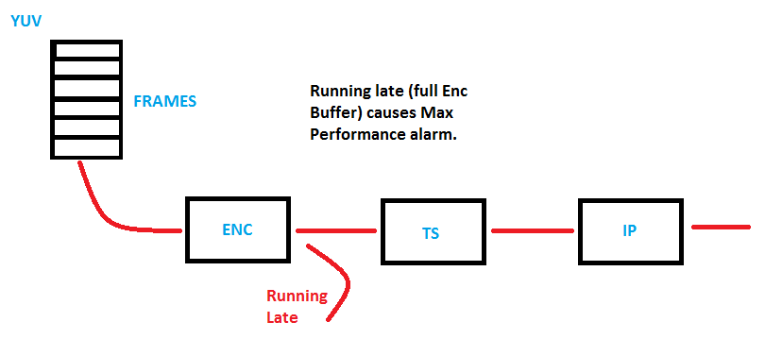
Looking at the above diagram, if for some reason there is an issue with the output of the MFEL, and if there are no Running Late alarms, then the output issue is not related to the encode process (probably) rather another mechanism within the MFEL.

