IP Transcode Input Statistics
When setting up the MFEL (Muse Live) for an IP input transocde, we need to ensure that the quality of the incoming stream is good. To do this we can check the Input Statistics panel on the relevant service source page.
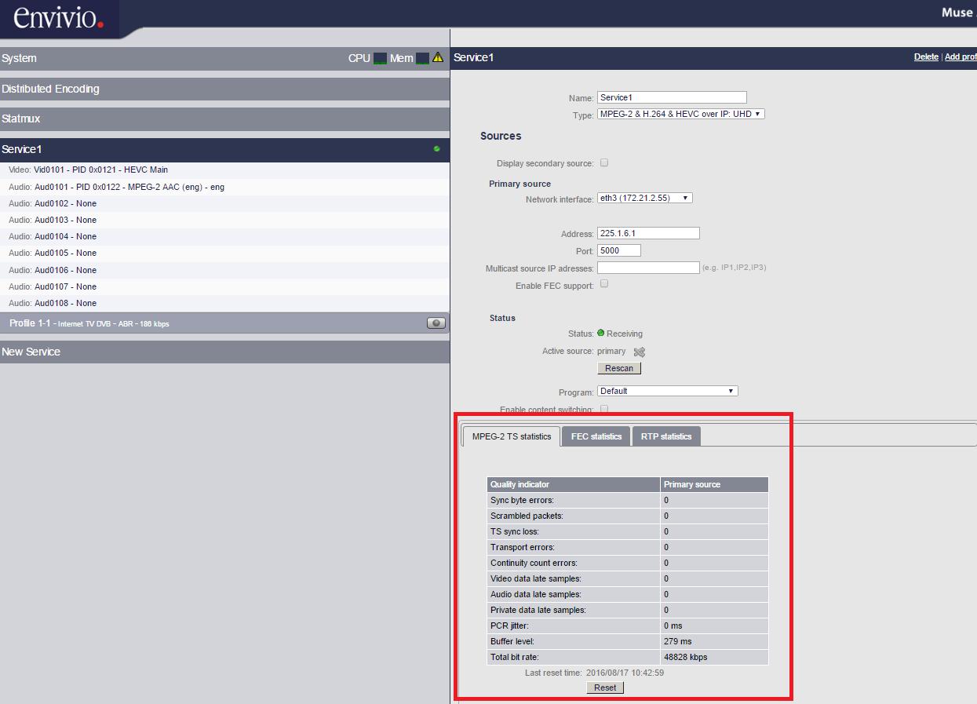
This panel gives us some useful information on the quality of the incoming IP Multicast by showing information such as Transport Errors, CC Errors, Total Bit Rate etc.

