Start a New Script
Aug 2017
 | 

As Terraform is a very small file (by todays standards) I generally create a new folder, and put the Terraform.exe executable in to that folder. I then keep Terraform and my script in that folder, creating a new folder containing a copy of Terraform for each script.
This is useful as Terraform creates other files to do with your scripts, and having lots of these in a single folder can be quite frustrating.
For this example, please do the following:
- Create a new folder
- Copy the Terraform.exe in to your new folder
- Create a new file in your preferred text editor and save it as “my_instance.tf”
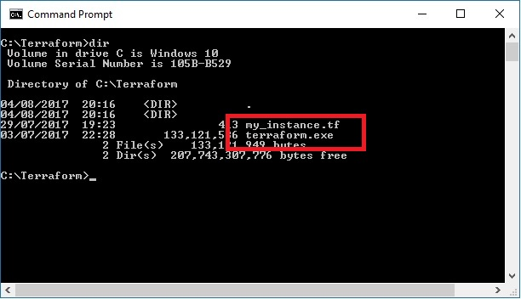
Paste the following text in to your “my_instance.tf” file and save it.
<sxh> provider “aws” {
access_key = "XXXXXXXXXXXXXXXX"
secret_key = "XXXXXXXXXXXXXXXXXXXXXX"
region = "xxxxxxxx"
}
resource “aws_instance” “simple_example” {
ami = "ami-xxxxxxxx"
instance_type = "xxxxxxxx"
key_name = "xxxxxxxx"
security_groups= ["xxxxxxxx"]
tags {
Name = "terraform-instance"
}
} </sxh>
As you go through each section of this guide, enter the relevant details in this script and save it each time. At the end of the guide you will have a finished script that you can test.

