Setting up the Slave UMDs
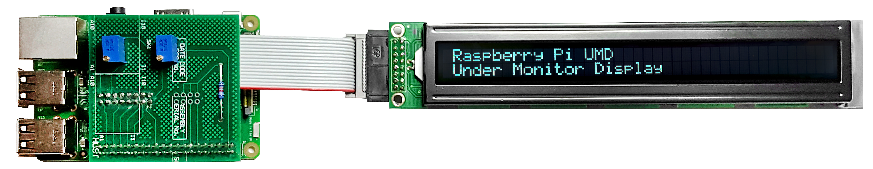

Slave Raspberry Pi(s)
The slave Raspberry Pi(s) download the latest 'my_data.txt' from the Master Raspberry Pi (once a second) using a 'wget' command, this means that each slave knows what to display. The my_data.txt file is downloaded every second, so changes to the file via the web interface propagate through the UMDs very quickly.
The 'my_data.txt' file has 8 lines, each line is for a particular display, so for example, line 1 & 2 are for LCD1 and reference monitors 1 and 2. Lines 5 & 6 are for LCD and reference monitors 5 & 6.
The setup of the slave UMDs is very simple compared to the Master. Setup Raspbian, copy some files and away you go.

Set Static IP Address
To set a static IP address, we need to login to the RPi via SSH and change the following file:
The default login is username: pi and password: raspberry (if this is an existing unit that is misbehaving, the login will be pi and Ericss0n)
/etc/dhcpcd.conf
Enter the following
sudo nano /etc/dhcpdc.conf
Add these lines to the end of the file (default is dhcp) using your own IP Address details
eth0
static ip_address=192.168.1.11/24
static routers=192.168.1.1
static domain_name_servers=192.168.1.4
Use Ctrl-X to exit and Y to save, now reboot the pi and connect to the new address

Raspi Config
From the terminal, run:
sudo raspi-config
You will see the following menu, there are several items we want to change here.
┌────────────────────┤ Raspberry Pi Software Configuration Tool (raspi-config) ├───────────────────────────┐
│ │
│ 1 Expand Filesystem Ensures that all of the SD card storage is available to the │
│ 2 Change User Password Change password for the default user pi) │
│ 3 Boot Options Choose whether to boot into a desktop environment or the command line │
│ 4 Wait for Network at Boot Choose whether to wait for network connection during boot │
│ 5 Internationalisation Options Set up language and regional settings to match your location │
│ 6 Enable Camera Enable this Pi to work with the Raspberry Pi Camera │
│ 7 Add to Rastrack Add this Pi to the online Raspberry Pi Map (Rastrack) │
│ 8 Overclock Configure overclocking for your Pi │
│ 9 Advanced Options Configure advanced settings │
│ 0 About raspi-config Information about this configuration tool │
│ │
│ │
│ <Select> <Finish> │
│ │
└──────────────────────────────────────────────────────────────────────────────────────────────────────────┘
Select Option 2 (Change User Password) - Change the password to Ericss0n
Select Option 3 (Boot Options) - Change to B2 Console Autologin Text console, automatically logged in as 'pi' user
Select Option 9 (Advanced) then A2 (HostNane) - Change the Hostname to UMD00n (where n is the display number)
Select Finish when asked to reboot select Yes

Update RPI
Even if you downloaded the latest version of Raspbian, chances are there are some updates. To update the RPi use the following command line:
sudo apt-get update && sudo apt-get upgrade -y
This will most likely take a few minutes on a new install.

Create Folder, Copy Files, Set Permissions
To hold the UMD LCD files, create a folder in your home location called Python and give the following rights:
mkdir /home/pi/Python
sudo chmown www-data /home/pi/Python
sudo chmod 777 /home/pi/Python
We need to copy the files to the /home/pi/Python location, for the Slave there are four files:
- launchUMD.sh - A script to auto start the UMD at boot
- getData - This is the script that gets the updated my_data.txt file
- my_data.txt - This holds the LCD data text, and downloaded from the Master via wget commands
- UMDisplay02.py - The Python code that runs the LCD
These files need to be copied to the /home/pi/Python location
sudo chmod 777 /home/pi/Python/*

Edit getData File
The getData file contains the wget command that pulls the latest version of my_data.txt from the Master Pi. The my_data.txt contains the 8 lines of text for the four LCD displays (2 lines for each LCD).
Example my_data.txt
UPPER MONITOR (1) - H264 SD
LOWER MONITOR (2) - H264 HD
UPPER MONITOR (3) - HEVC SD
LOWER MONITOR (4) - HEVC HD
UPPER MONITOR (5) - UHD TV
LOWER MONITOR (6) - HDR UHD TV
UPPER MONITOR (7) - Sky Cinema HD
LOWER MONITOR (8) - Sky Sports UHD
Example getData
sudo wget -q http://192.168.1.11/my_data.txt >null -O my_data.txt
In the getData file we need to replace the IP Address with the IP Address of our Master UMD Pi.
To change the IP Address use:
sudo nano /home/pi/Python/getData
You could use HostNames, but I have found hostnames on Pi's pretty unreliable.

Edit launchUMD File
The launchUMD file contains a link to the UMDisplay0x.py file
#!/bin/sh
# launchUMD.sh
# navigate to home directory, then to this directory then launch script
cd /
cd home/pi/Python
sudo python UMDisplay01.py &
cd /
This file needs to be edited so that the line sudo python UMDisplay1.py & points to the correct UMD Device (so if this is your third UMD Device it needs to contain UMDisplay03
sudo nano launchUMD.sh

Edit UMDsiplay0x File
The UMDisplay0x file contains the code to write to the LCD. We do have to edit this file to tell it which of the two LCD lines to display from the my_data.txt file
# write line 1 and 2 to the LCD
lcd_string(" " + line1,LCD_LINE_1)
lcd_string(" " + line2,LCD_LINE_2)
Line1 refers to the line in the my_data.txt file. So if this was UMD3, then you would want lines 5 and 6. so this would be:
lcd_string(" " + line5,LCD_LINE_1)
lcd_string(" " + line6,LCD_LINE_2)
LCD_LINE_1 refers to the Line on the LCD (Line 1 is the top, line 2 is the bottom)
Edit the UMDisplay0x.py file by using:
sudo nano /home/pi/Python/UMDisplay0x.py

Test LCD Code
Assuming that you have connected the LCD to the RPi (via the ribbon cable and driver board) then you can test the code that runs the LCD, on the slave this file is the:
UMDisplay0x.py (where x is 2, 3, 4 4 etc.)
This is a python script, you can run this script by entering at the command line:
./UMDisplay02.py
If you are lucky, you will see some text on the LCD, chances are however you will not. This is due to the Potentiometer settings on the driver board, you will need to change these to set the Backlight and LCD intensity.
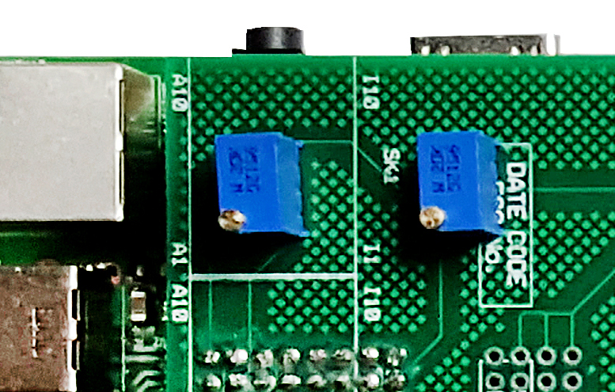
Adjusting these two potentiometers will allow you to balance the text and backlight intensity to get the brightness level you require.

Making it Automatic
The last part is to automate the process of starting the UMD code. For this we need to add the launcher file to a system file on the RPi.
Edit the file /etc/rc.local to automate this process.
sudo nano /etc/rc.local
add this line at the end:
sudo ./home/pi/Python/launchUMD.sh
To test this, reboot and the LCD should start up automatically (the LCD won't clear on boot, but wait for the “Waiting for 5 Seconds for Network Start” message).

UMDsiplay0x.py File Differences
There are a couple of differences between the Python scripts on the Master and the slaves, here is an overview of those differences.

#import
On the #import section there is one difference
Master Slave
#import #import
import RPi.GPIO as GPIO import RPi.GPIO as GPIO
import time import time
import socket import socket
import fcntl import fcntl
import struct import struct
import os
On the slave there is an extra library that is imported (the os library). The os library allows the running of command lines from within Python.

Program Start
At the Program Start section of the Python code there is an extra line.
## Get text file from master Pi UMD001 (runs the file getData in the Python folder)
os.system("/home/pi/Python/getData")
The os.system(“/home/pi/Python/getData”) calls the getData script. This is the script that pulls the latest my_data.txt file from the UMD Master. This command is the one that needs the extra #import library.

