Second Locking Code
Nov 2019

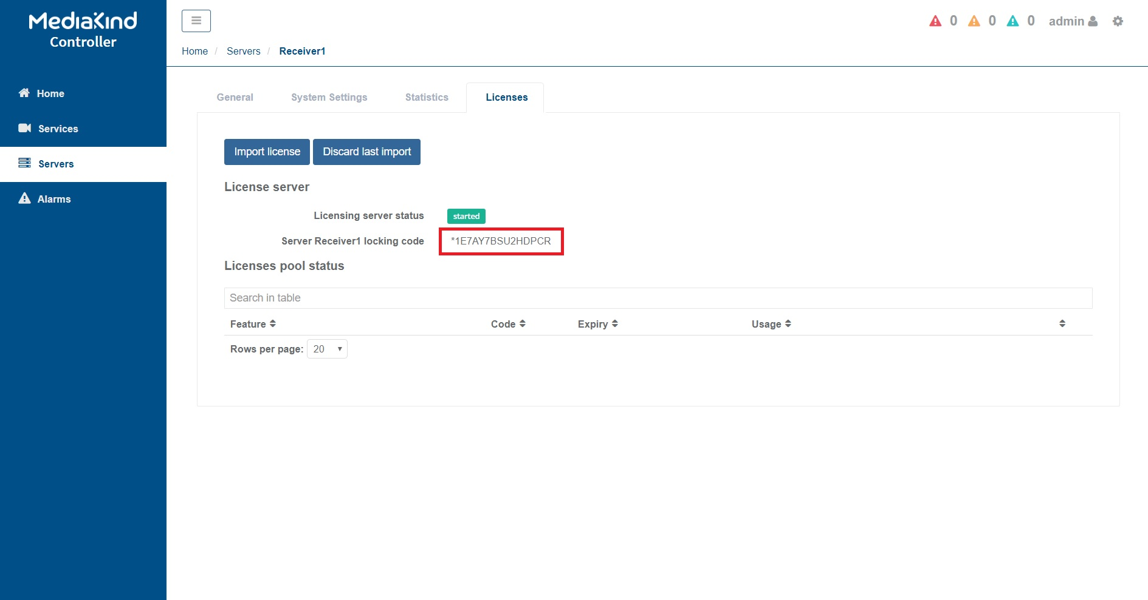
Introduction
When looking at the RX1 GUI, under servers we can see the Locking code for license generation.
However for some licenses a second locking code is required, this code (at the time of writing) is only available from the command line.
Using either SSH or Keyboard/Mouse login to the RX1.
username: mfeng
password: 2u4y&C
from the command line, run the following:
cd /opt/ericsson/license-manager/bin/
sudo ./echoid -d
(you will have to re-enter the password)
Sentinel RMS Development Kit 8.6.1.1401 Host Locking Code Information Utility
Copyright (C) 2014 SafeNet, Inc.
ID PROM : 0x0
Disk ID : 0x4A1366D6
Host name : ENV-4E-963668
Ethernet address[1] : 74-FE-48-28-6E-A0
Hard Disk Serial[1] : 002732101E4C
CPU Info String : GenuineIntel Intel(R) Xeon(R) CPU E3-1245 v6 @ 3.70GHz 6 14 9
UUID : 4A30AAC8-F4E7-7241-8D20-18132D95D984
Locking Code 1 [1] : 2018-*1E7 AY7B SU2H DPCR
Locking Code 1 [1] (Old Style) : 2018-5F41F
---------------------------------------------------------------------
Ethernet address[2] : 74-FE-48-28-6E-A1
Hard Disk Serial[1] : 002732101E4C
Locking Code 1 [2] : 2018-*162 UJRZ V257 RZFA
Locking Code 1 [2] (Old Style) : 2018-6F41B
---------------------------------------------------------------------
You will get an output similar to the above with Locking Code 1 (this is the locking code you can see from the GUI) and Locking Code 2, the second locking code required for some licenses.

