Rear Panel Connections
Nov 2017

Here are the rear panel connections on the MFCP (as of launch).
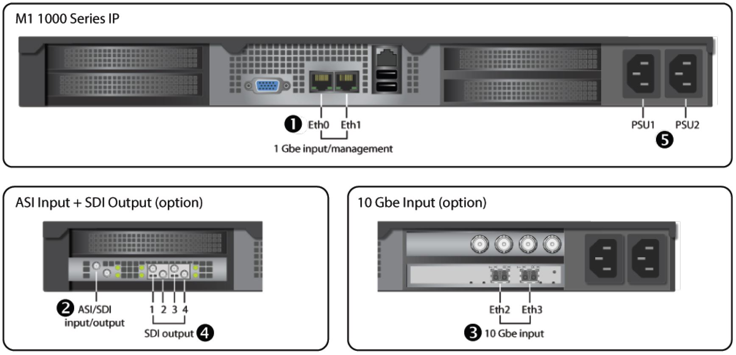
The four normal BNC connectors top right are for ASI Inputs.

