nCompass Control
Apr 2424

nCompass Control is not a single application, but a suite of applications, the main three applications are:
Equipment Setup.
Equipment Status Manager (ESM).
Profile Manager
Equipment Setup:
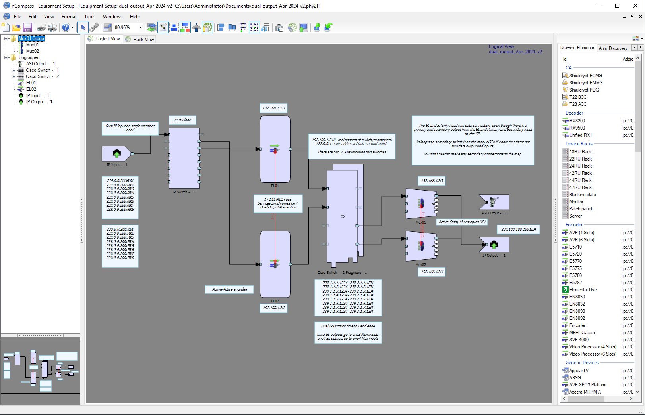
This is a tool to create a map that consists of physical items such as hardware components and fixed addressing.
Equipment Status Manager has three main tasks:
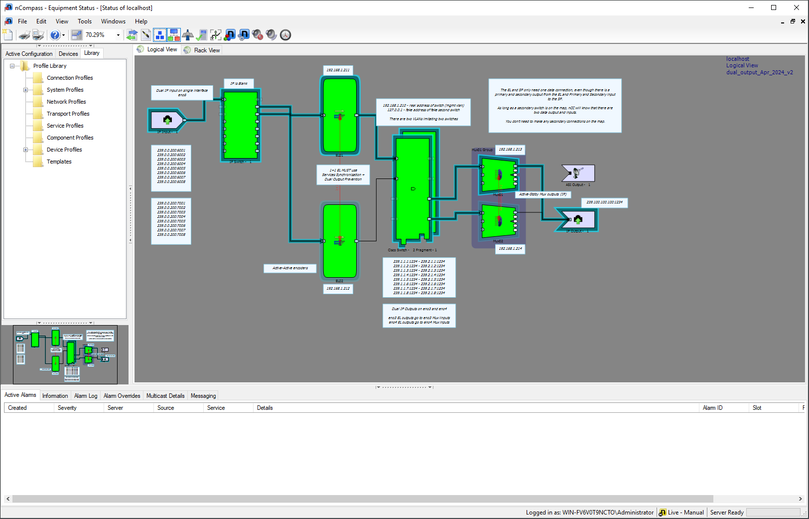
1. Creation of Service Profiles
2. System Health Monitoring
3. Manual Switching of devices / services
Profile Manager
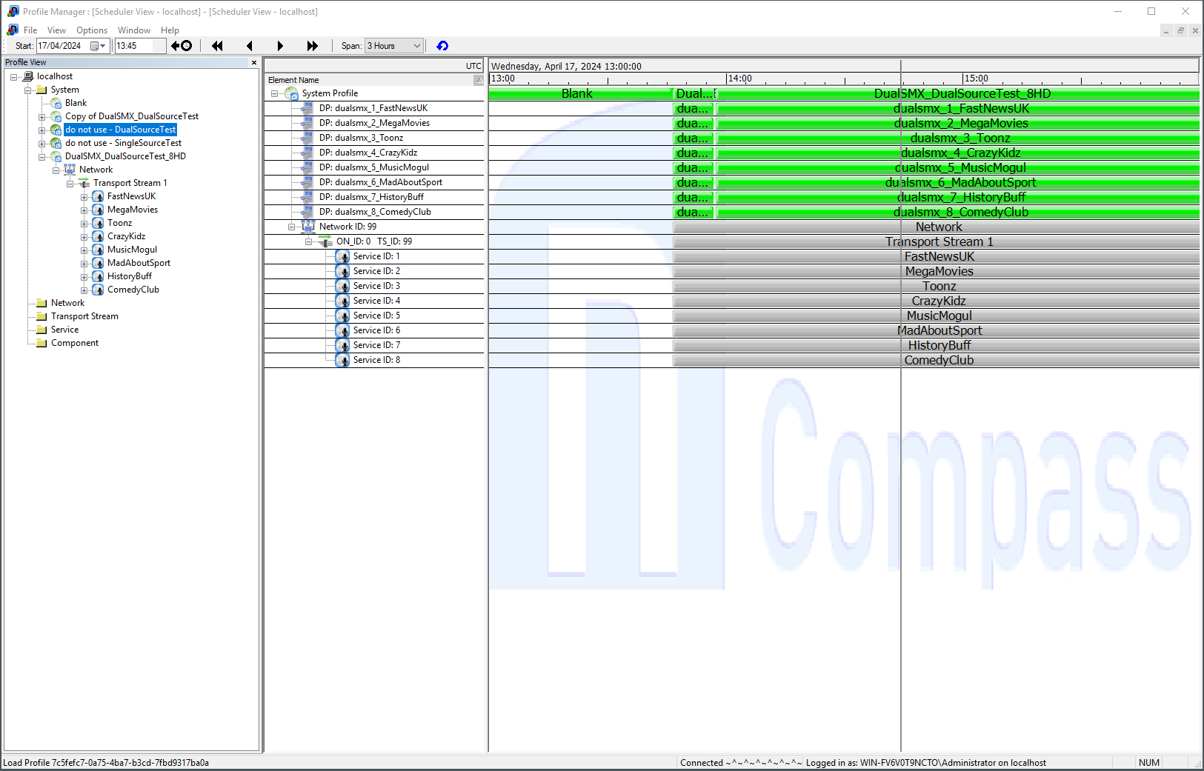
This allows creation and scheduling of system profiles.

- nCC Profile Location

