HEVC Decoding Options
May 2017

To get to the RX8200 page that shows the fitted hardware, click the Device Info tab (second tab) then click the Modules button (you need to be in Advanced view to access these menus)
You should see a page that resembles the image below:
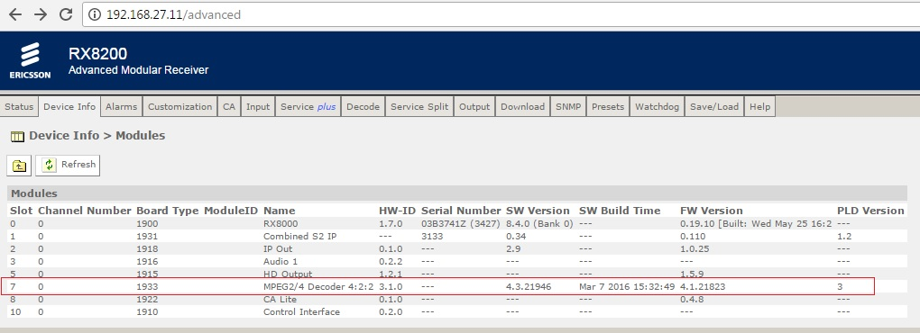

For existing RX8200s there is an option for them to decode HEVC, depending on what option cards are fitted. Firstly there has to be a 4:2:2 decoder card, and this card has to be one of the following types:
1933 (1080i only)
1936 (1080i & 1080p decoding)

