EL 1+1 Sync
Nov 2023

Stat Mux in Aquila Live is pretty much the same from the user perspective as it has been since the inception of Encoding Live / MKSP and nCC (from a user perspective). There are a couple of places that synchronisation is used and we will explore those here.

Services Synchronisation
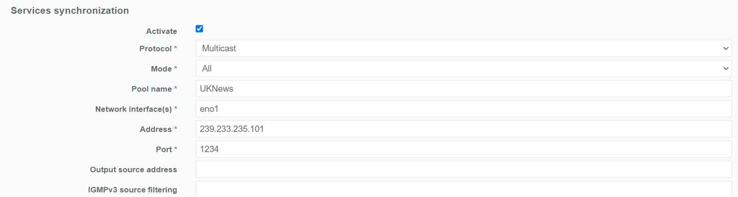
This setting is for ensuring that the encoded streams from both encoders essentially has the same GOP/PCR/PTS etc (assuming you configured the same GOP length/Structure in the encoding page). This helps with switching as downstream devices don't have to deal with wildly differing PCR values.
This section is used in Broadcast and Streaming. In Broadcast and Streaming, it syncs the services from two encoders (so 1+1) so that they are running with the same timing values such as PTS, PCR etc.
Additionally, for streaming this can be combined with a section below called 'Variants' This allows Two encoders running in 'Split' mode to each output different ABR streams from the same ladder, and have the two sets of ABR output streams coming from the two encoders to be synchronised in time.
Tick the 'Activate' check box to enable Services Synchronisation, then fill out the following fields:
Protocol Multicast (Redis can be used in Cloud implementations where multicasts are not available)
Mode All (no other option)
Pool Name You can use any name, it must be unique. I generally use the channel/service name.
Network interface Set the network interface you wish the synchronisation comms to travel over.
Address The Multicast Address you wish to use (can be the same for all services)
Port Set the port you wish to use (can be the same on all services)
The Multicast Address and Port can be the same as long as the Pool Name is unique on all services
This has to be configured the same on both 1+1 Encoders (or split encoders)

Dual Output Prevention
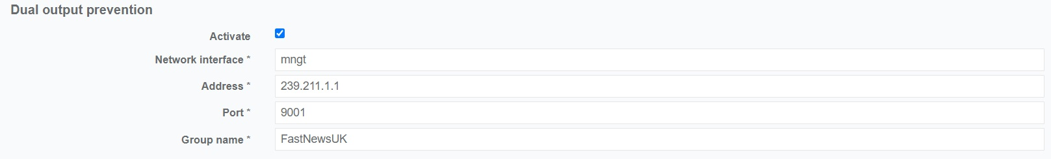
Dual Output Prevention ensures that two encoders running in a 1+1 setup have only one encoder actually outputting a TS Multicast. Both encoders are encoding content, both are creating a TS, and (if required) statistical multiplexing, but the 'backup' encoder has its output 'muted'
This section is similar to the 'services synchronisation' but has a few less settings:
Network Interface The interface you wish to run the comms on (in this case, mngt is a teamed interface)
Address The Multicast address for the messaging (can be the same for each service)
Port The Multicast Port (can be the same for each service)
Group name Must be a unique value, I normally use the channel/service name.
The Multicast Address and Port can be the same as long as the Pool Name is unique on all services

Remember that both 'Services Synchronisation' and 'Dual Output Prevention' only run in 1+1 scenarios.

