Cisco VLANs and Trunks (danscourses)
Nov 2017
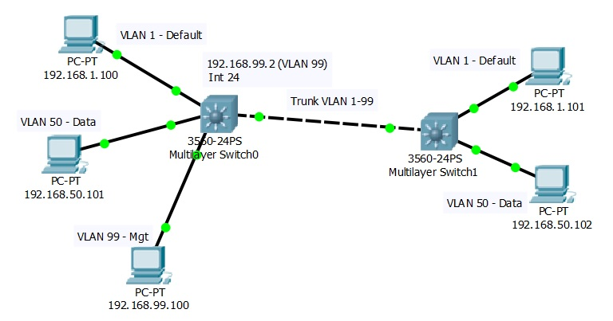

Introduction
Before we start, I have ripped these videos from YouTube. I will give the link to the first video, the rest are easy to find from there. YouTube user danscourses made these videos, and I take no credit for any of the content.
YouTube User: danscourses Link to the first video in the series: https://www.youtube.com/watch?v=aBOzFa6ioLw
That said, the first few videos are here, to get you started. I recommend watching the videos from Part 1, mainly because a tool is being used called Cisco Packet Tracer that you can download (you will need to make an account) and follow the examples with. While the content of the first few parts is easy, you will see how to use the Cisco Packet Tracer, so stick with them, they are quite short, and the content is really useful.
Cisco Packet Tracer - packettracer71_64bit_setup_signed.zip
Example Topology - alan_vlan_03.zip

Videos
VLANs and Trunks for Beginners - Part 1 vlans_and_trunks_for_beginners_-_part_1.mp4
VLANs and Trunks for Beginners - Part 2 vlans_and_trunks_for_beginners_-_part_2.mp4
VLANs and Trunks for Beginners - Part 3 vlans_and_trunks_for_beginners_-_part_3.mp4
VLANs and Trunks for Beginners - Part 4 vlans_and_trunks_for_beginners_-_part_4.mp4
VLANs and Trunks for Beginners - Part 5 vlans_and_trunks_for_beginners_-_part_5.mp4

