Circuit Diagrams and PCBs
Mar 2017

Original PCB
Below is the original PCB for this project, I have had some of these made and they work perfectly.
You can download the PCB and Gerber files HERE. If you are using a Raspberry Pi 1/2/3 then this PCB is fine, it will also work on a Raspberry Pi Zero, but there is a better PCB for that below.
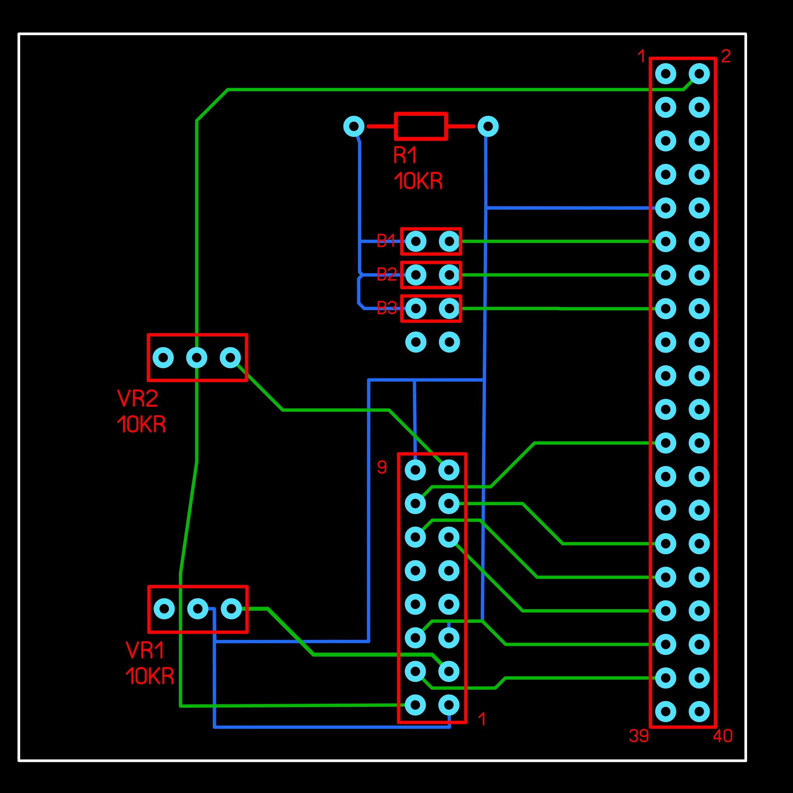

New PCB
The following PCB is much better for the Raspberry Pi Zero as it is the same size. The top mounting holes will also line up if you want to use this PCB on a Raspberry Pi 1/2/3 as well.
You can download the PCB and Gerber files HERE.
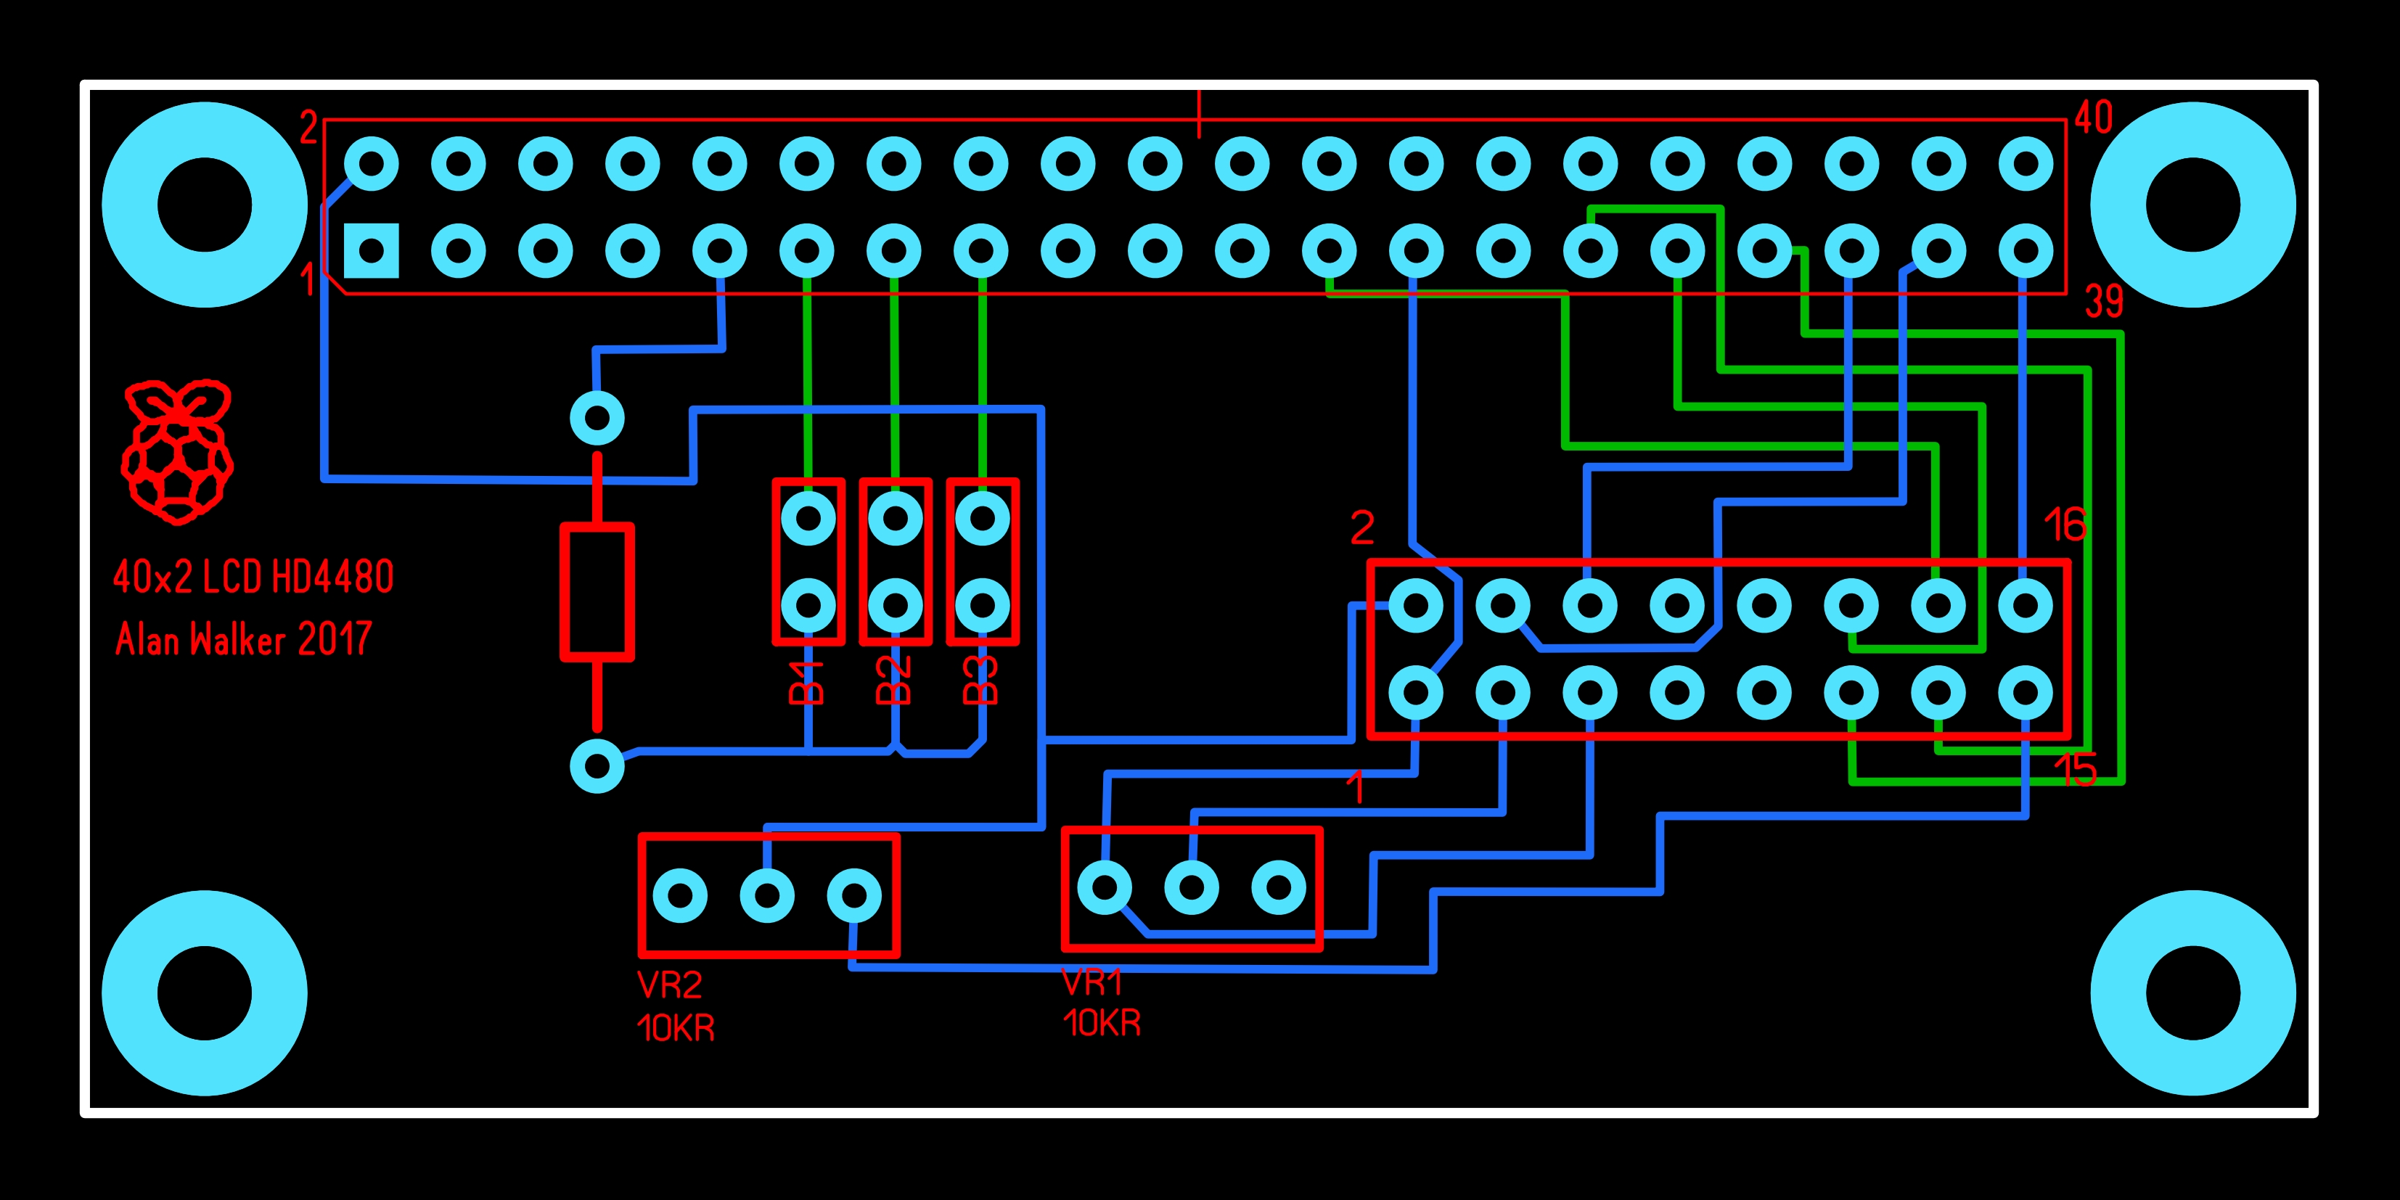

Circuit Diagram
There is not really a circuit diagram as there are no components for this project. It really is just two connectors and two Variable Resistors (for contrast and backlight).
Below are the connections from the 16Way LCD header to the 40Way Raspberry Pi header.
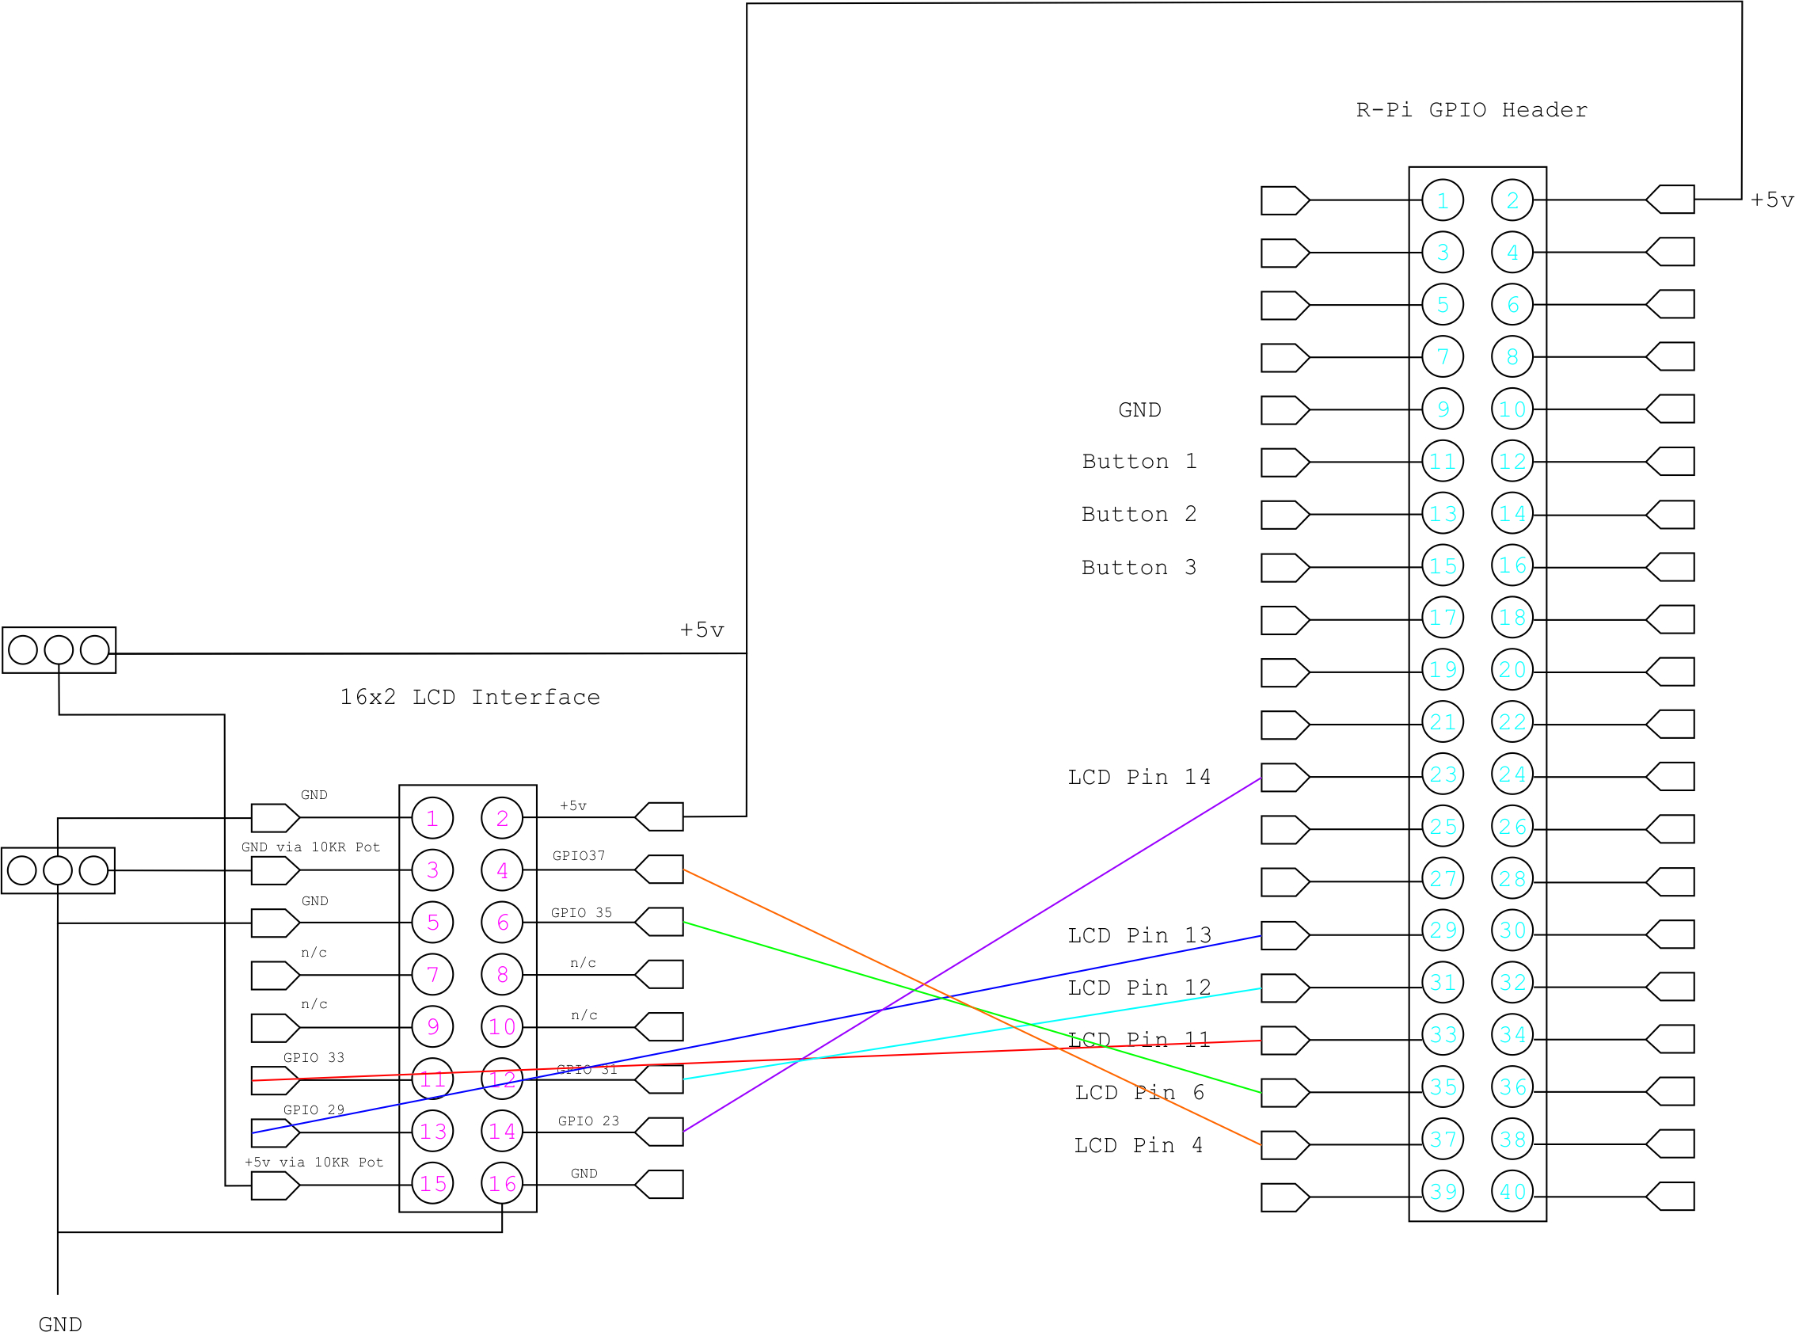

Here are the functions of each Pin


