Aquila Live
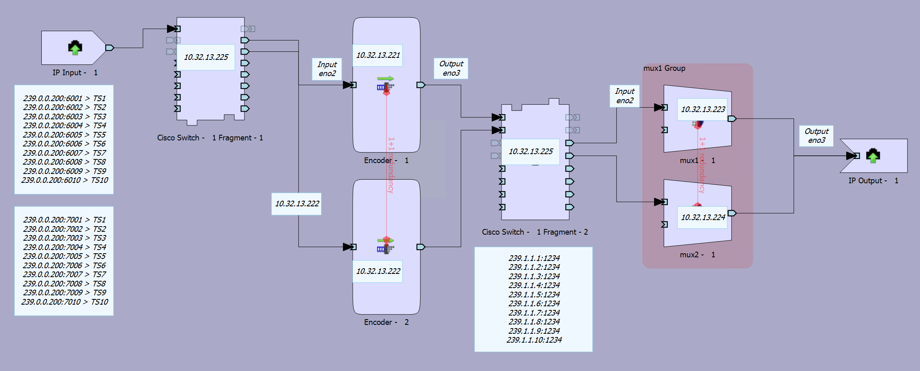
Nov 2023

Aquila Live, previously Aquila Broadcast, Previously Linear Broadcast etc. Basically, an nCompass Controlled solution with Encoding Live and Multiplexing.
I am starting this page from Aquila Live version 7.
There are two major differences between Aquila Broadcast (so everything up to v5.0.9) and Aquila Live v6 and onwards. These are:
1. Aquila Live V6 moved from Centos (v7.8) to Alma Linux (v8.7 at the time of writing)
2. Aquila Live moved from RPM (v5) to cRPM (Containerised) installs, using dDocker/PODs/Containers.
For point 2, the user will mostly see no difference, but a lot of ways of working from v5 will not work, because now you have to work inside a POD rather than just at the OS level.

- Aquila Live Stat Mux
- EL 1+1 Sync
- nCompass Control Interface Down Alarms
- IGMP Snooping Groups
- Force IGMP version on EL and Mux

