Windows Audio with nVidia ShadowPlay

nVidia ShadowPlay is a fantastic piece of software shipped with nVidia graphics cards that allows the recording of the screen. A user can record either their desktop, great for tutorial videos, or they can record their gameplay, nice for YouTube videos. ShadowPlay is so efficient that it only adds around 2% to the processor overhead on modern PCs.
While ShadowPlay is very good, there is one thing that annoys me with my videos, and that is the audio. I love recording my games, but don't want my chatter, or the chatter of others in them (unless I choose). To resolve this I have decided to use two audio devices on my computer, via a mixer. However I keep forgetting the settings, so I am documenting them here.

Hardware
The hardware for this is quite simple, I am using the the following:
- OnBoard Soundcard
- USB Mixer
- TurtleBeach Headset
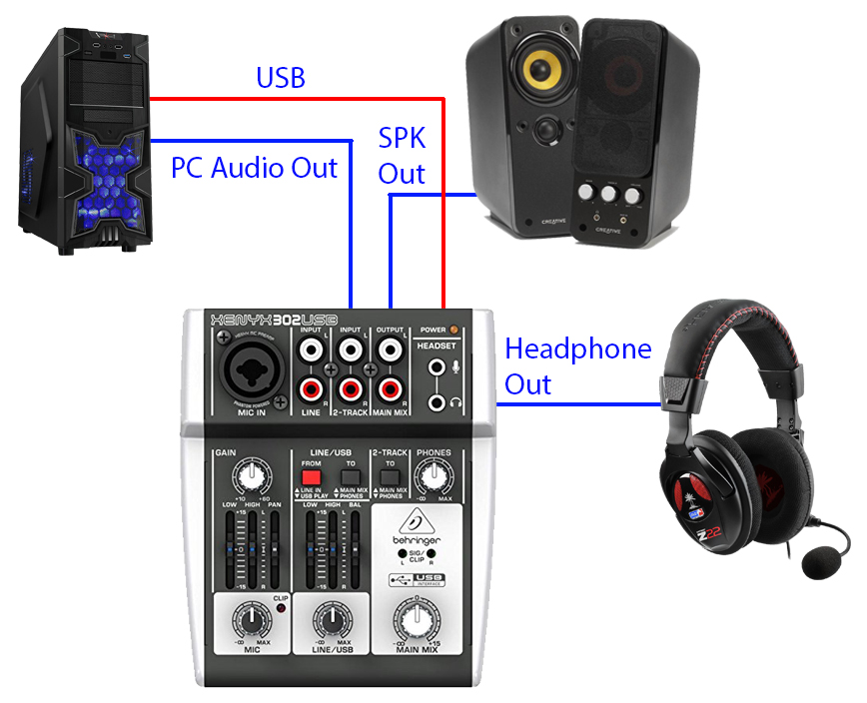
The USB Mixer is connected to the PC via USB, the USB supplies Power, and the Mixer is also a Windows USB Audio Device (so works as a soundcard in it's own right).
The Onboard Soundcard output is fed in to the USB Mixer 2-Track input.
The Speakers and Headpohnes are connected so that I can switch between listening to my headset, or on a set of speakers.

Software Settings

