TOP CPU Usage
Mar 2020

Overview

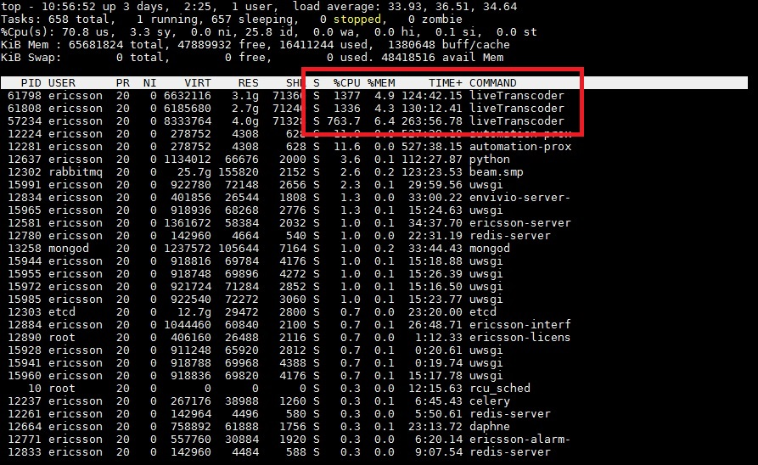
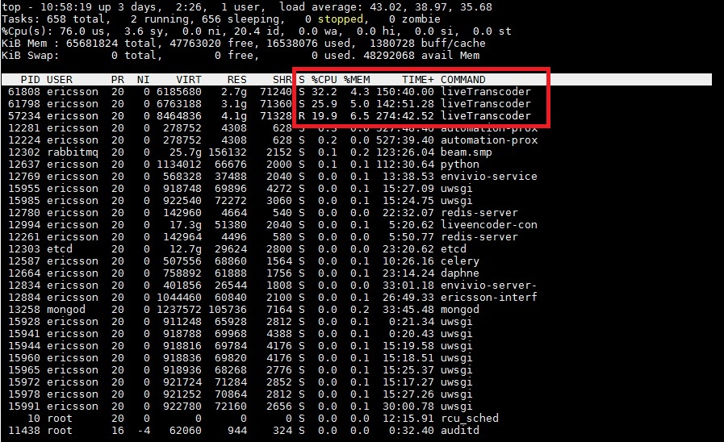
Top is a great tool for showing how much CPU and memory is being consumed on a server, on a multi CPU system however, the CPU percentages can be confusing. Look at the example below.
The figures for the highlighted processes are defined as 100% chunks of each CPU (or part of a CPU) so when we see a CPU usage of '1377' we know that that process is using nearly 14 CPUs worth of power (not necessarily 14 CPUs, that is different, but consuming 14 CPUs worth of resource that could be spread across more than 14 CPUs).
This makes it challenging to work out how much CPU is being used, as you need to know the number of CPUs in the first place.
Thankfully, TOP is able to show CPU usage as a percentage of total available CPU. To do this, when TOP is running press “shift - i”
Above we can see that the highlighted processes now show as a total CPU consumed figure, which is much simpler to work with.

