MFEL - Media First Encoding Live (All Versions)

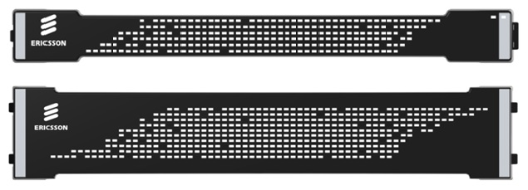

This page contains information for both the MFEL product (v6/v7/v8/vX) and specific CentOS tools. However v8 Specific information is in the Version 8 pages.
The Media First Live Encoder (formerly Muse Live) is a software based encoder supplied by Ericsson (acquired from Envivio) that is available as a software only, or appliance (appliance is where the hardware and software are supplied pre installed to the customer).
- G6 1U 1052 Chassis
- G6 2U SuperMicro UHD Chassis
- MFEL Versions
- Restart Muse Service
- Generate Support Package
- Silence Unconnected Network Interface Alarms
- Default NIC Configuration Files
- NIC Link Status
- Silence Duplicate Address Detection Alarms
- Console Commands
- Traces
- Clear Traces
- License Page
- MFEL File Locations
- YUM
- Failed Muse Install 1080p SDI Board
- Muse Logs Location
- G6 2U Node Distribution
- IP Transcode Input Statistics
- Mount USB Stick MFEL
- Unmount USB Stick MFEL
- Check Temperature
- Check Running Encoder Processes
- Installing htop
- Using htop
- How to set the CentOS-Base.repo
- Simple EPEL Install
- NUMA Cores
- numactl
- WORKAROUND for Bug 41288 - [Performances] Controlling NUMA Core Operation
- tcpdump
- Running Late - Max Performance
- Find Running Late Alarms
- Flush Cache
- HDR Advanced Parameter Settings
- Standard Extreme Up!
- G6/G7 Hardware and Software
- StatMux Priorities
- Remove MFEL (Muse) Software
- MFEL Misnamed IP Ports
- MFEL Localisation
- Use Cron at License Period End
- IP Tables
- IOStat
- Disable IPV6
- ncdu - NCurses Disk Usage

