Square-division versus two-sample interleave (2SI)
Or in AVP terminology, Quad vs Interleaving

Quad (Square Division)
Quad (Square Division) is the way we started our AVP H.264 contribution. The 4K signal is presented as 4xHD-SDI (up to p30) or 4x3G-SDI (up to p60). Each input is a quarter of the image (quadrant).
As can be seen from the above diagram, each quadrant represents a part of the active 4K picture. There are two main issues that surround using Quad inputs in this way, and they are:
- Sync issues between quadrants
- Quadrant Order
If the quadrants are out of sync, then you can end up with an image that looks like four separate sources on the screen. The order of the quadrants can be confusing also. The first and last are generally the same (Top left first, bottom right last) However depending on the actual order, the middle two can get mixed up, the two orders are:
Method 1 Method 2
Top Left Top Left
Top Right Bottom Left
Bottom Left Top Right
Bottom Right Bottom Right

Two Sample Interleave (2SI)
Two sample interleave (two pixels) is a way of interleaving all of the parts of the image across the frame, still in quadrant format, to alleviate sync issues.
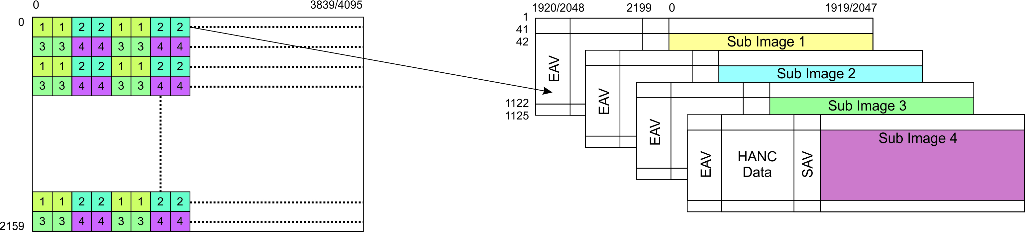
The interleaving is done two samples at a time, so from the top left quadrant (1) and the top right quadrant (2) we order the pixels 2×2. Hence the 112211221122 pattern. The same is also performed on quadrants 3 and 4. The two pixel interleave is alternated down the frame on each line.
Quadrant order is still an issue though, in fact more so than the square division format. In square division, if your quadrants are out of order, it's really obvious (except on extremely random patterns) it's like a mis-assembled jigsaw. However on 2SI, if you invert say quadrant 1 and 2, the result is quite subtle, and on still or slow moving material, it's not obvious at all. So great care still has to be take to ensure the quadrant order is correct.
The SDI specification now allows for the signalling of the SDI number in the SDI stream. On the AVP, if this SDI numbering is present, you can plug the SDI inputs in using any order, and the AVP HEVC card will work it out (in 2SI mode).
In Square Division QUAD mode, the picture is split in to four quadrants, each quadrant containg a quarter of the image.
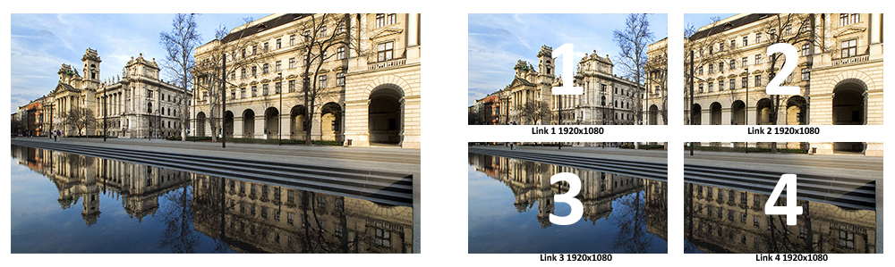
Each quadrant comprises exactly 1/4 of the UHD Image (so a 1920×1080 HD image)
For 2SI mode, each quadrant contains a quarter of the picture information, but as a fully decodable HD image.
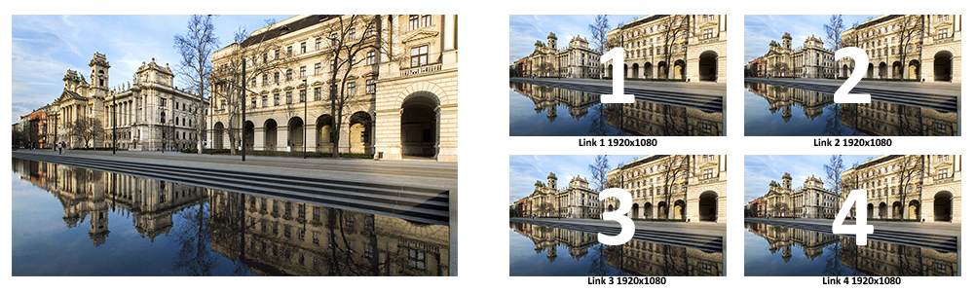
2SI method allows picture monitoring on standard 1080P displays as each link carries the whole image at ¼ of its original resolution

