Test Decoder Card
Oct 2018

Introduction
When testing the MFCP decode, it is possible that the decoder card may have failed, and that the MFCP has dropped to SW decoding. In 4K this my not be obvious if you are decoding some very simple content.
There are however a couple of tests that can be made to ensure that the decoder card is working (as much as we can tell).

Is the Decoder Card detected by the Driver?
Each time the MFCP is started, the driver communicates with the decoder card, we can see if the decoder was detected by looking for the driver in CentOs.
Run the command:
ls /dev
Among the listed files/folders you should see the following:
decoder0
sdi0
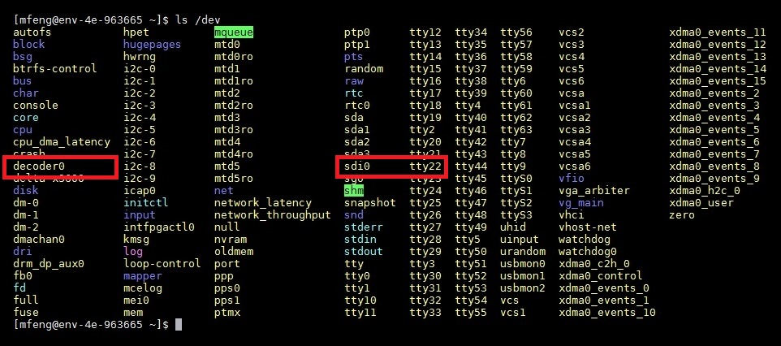
If these are missing, the card may have failed (or just failed to boot) if you restart the unit and still don't see these two entries then you may have a decoder card failure.
If these are not listed then there is a hardware or driver issue with the card. First step would be to try reinstalling.

When the Decoder is in use
From the command line, run:
lsmod | grep decoder
You should see an output similar to the following:
decoder 22463 1
decoder is the decoder module
22463 is the driver size in bytes, so this may change depending on your verions
1 is the number of decodes. So 0 means you are not decoding using the module, and 1-4 is decodes (1 UHD or up
to 4 HD)
For the SDI:
lsmod | grep sdi
sdi 17706 1
Last number is number of instances using driver. 0 means the device isn't used.


