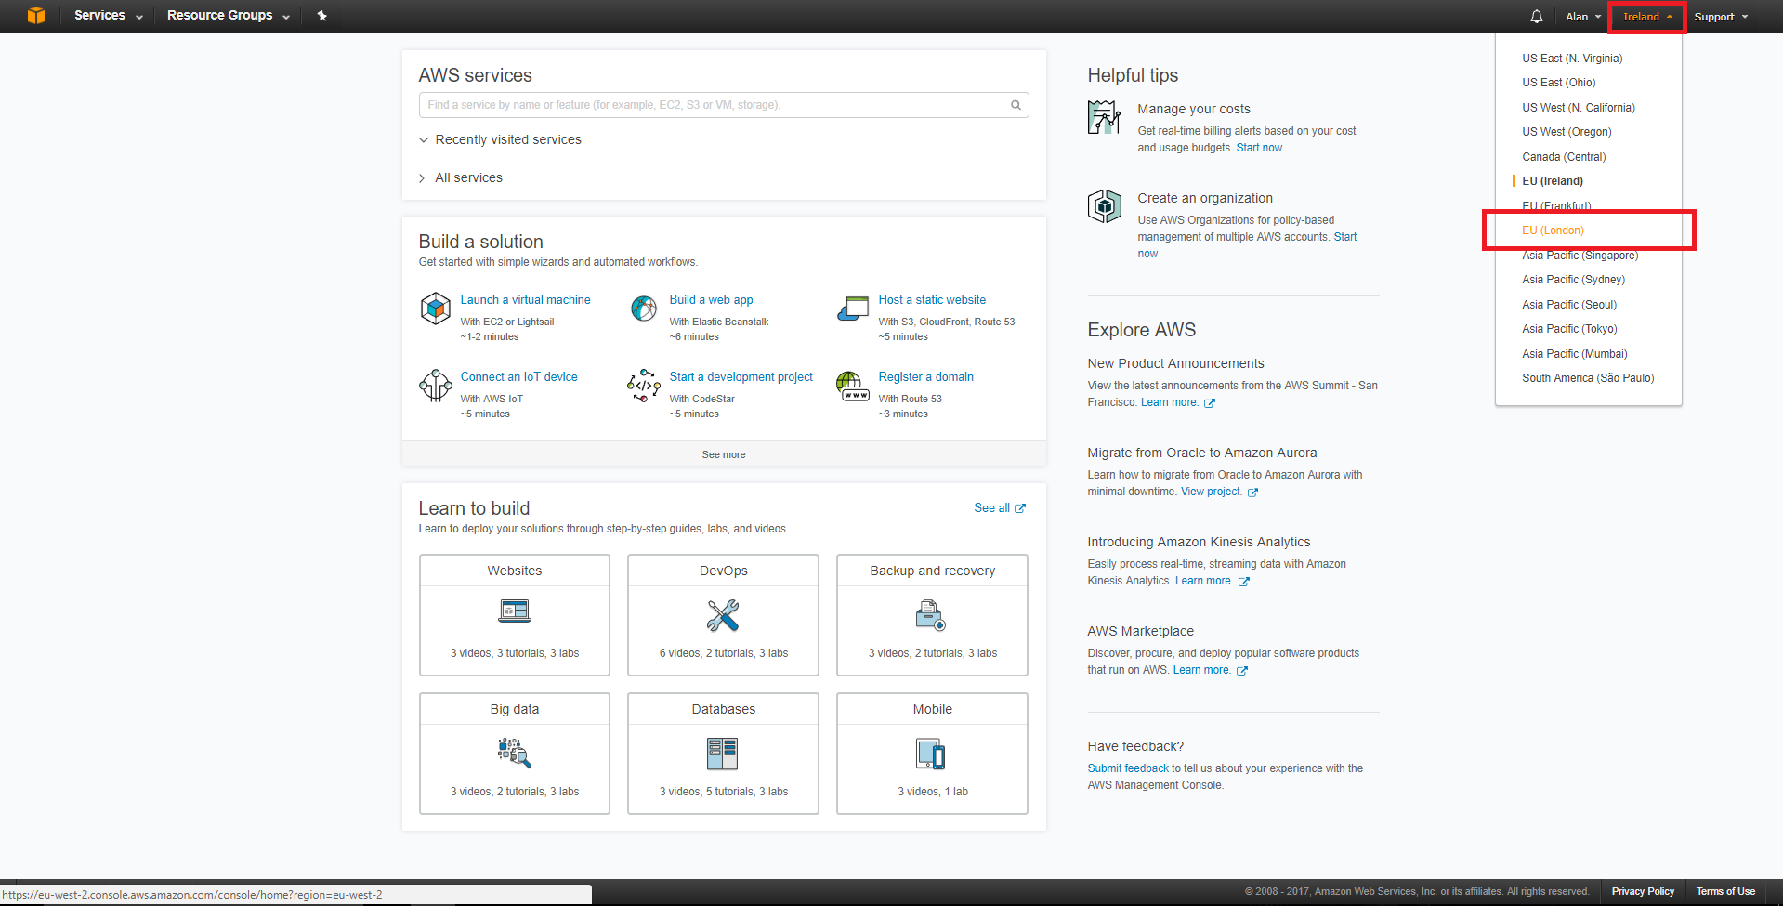
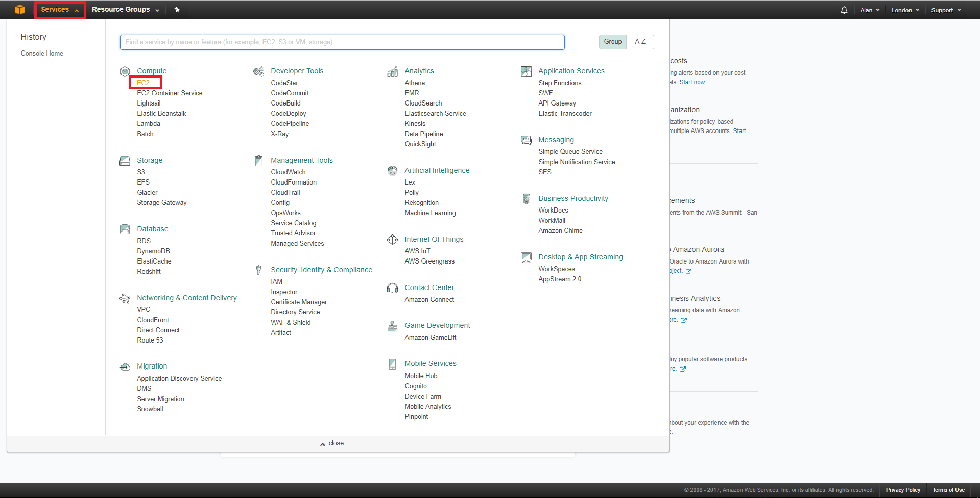
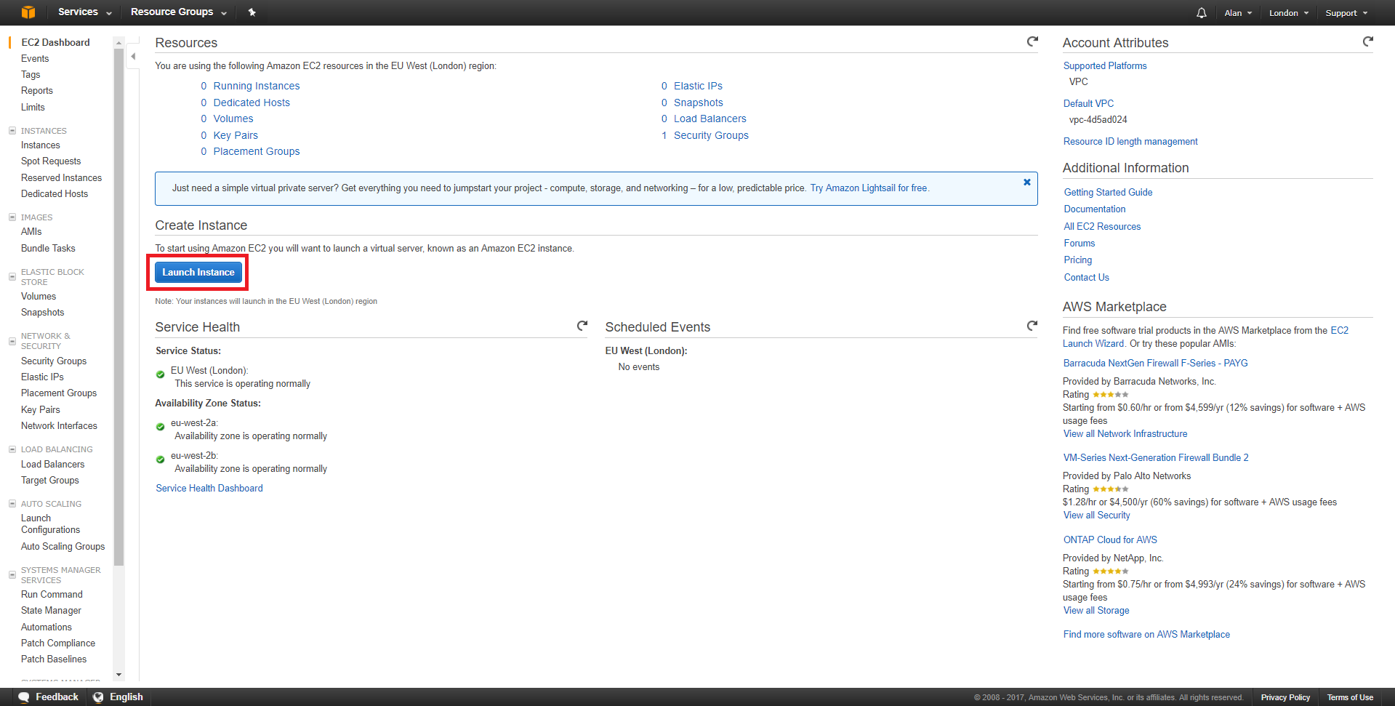
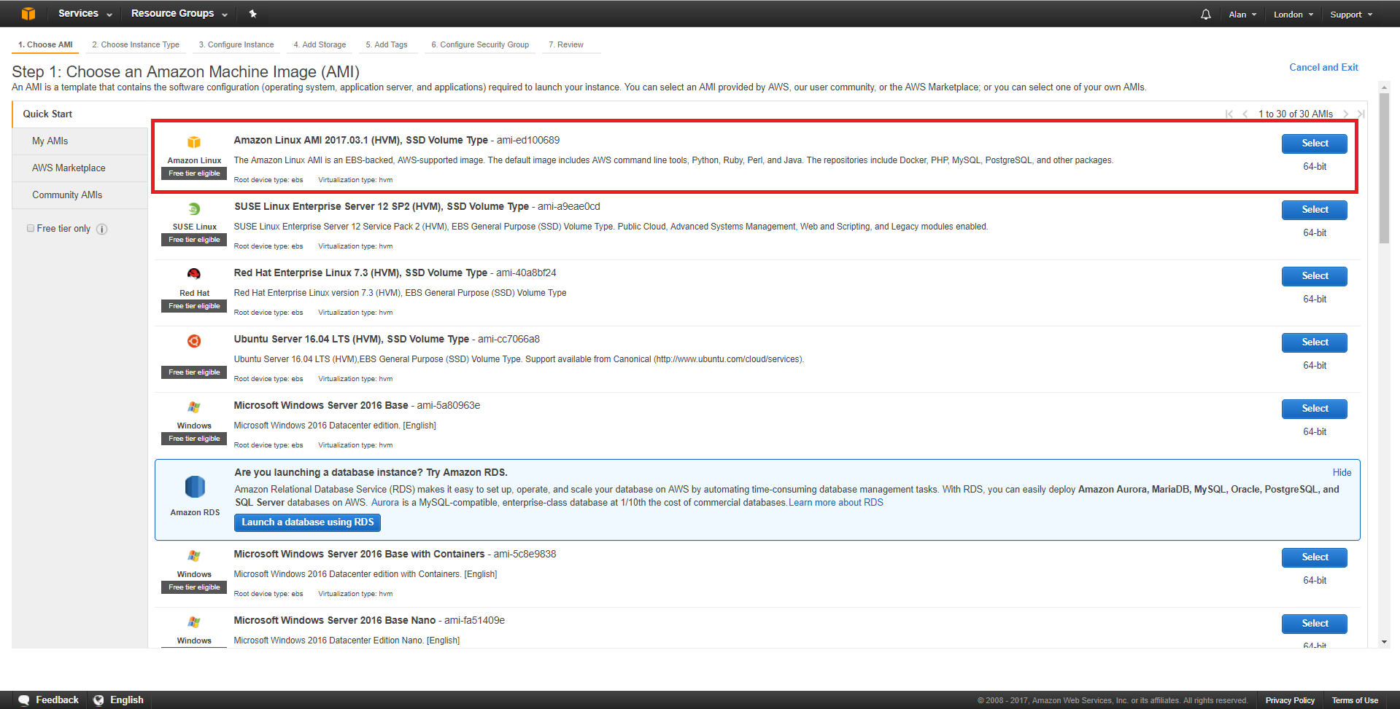
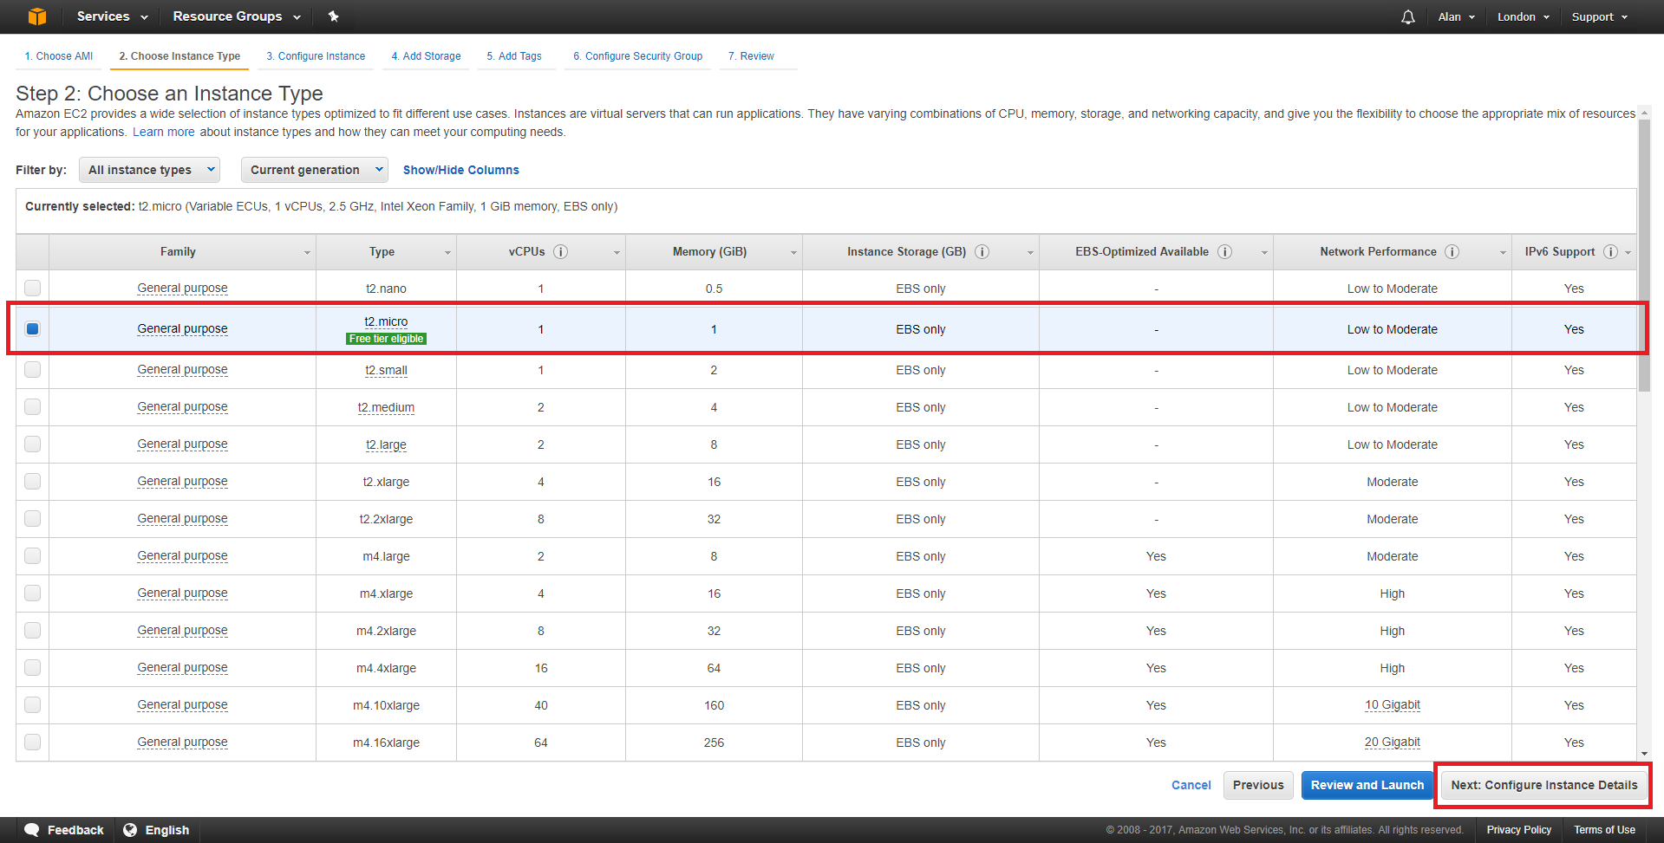
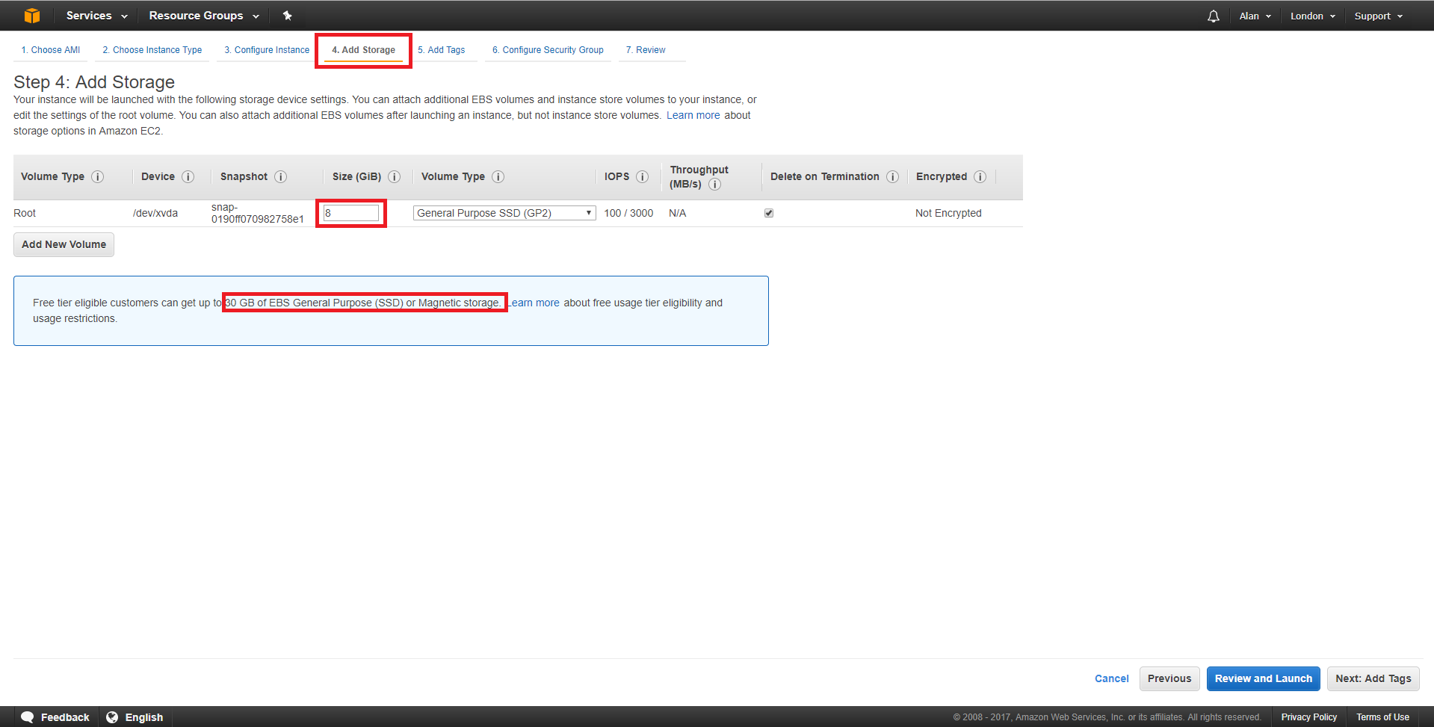
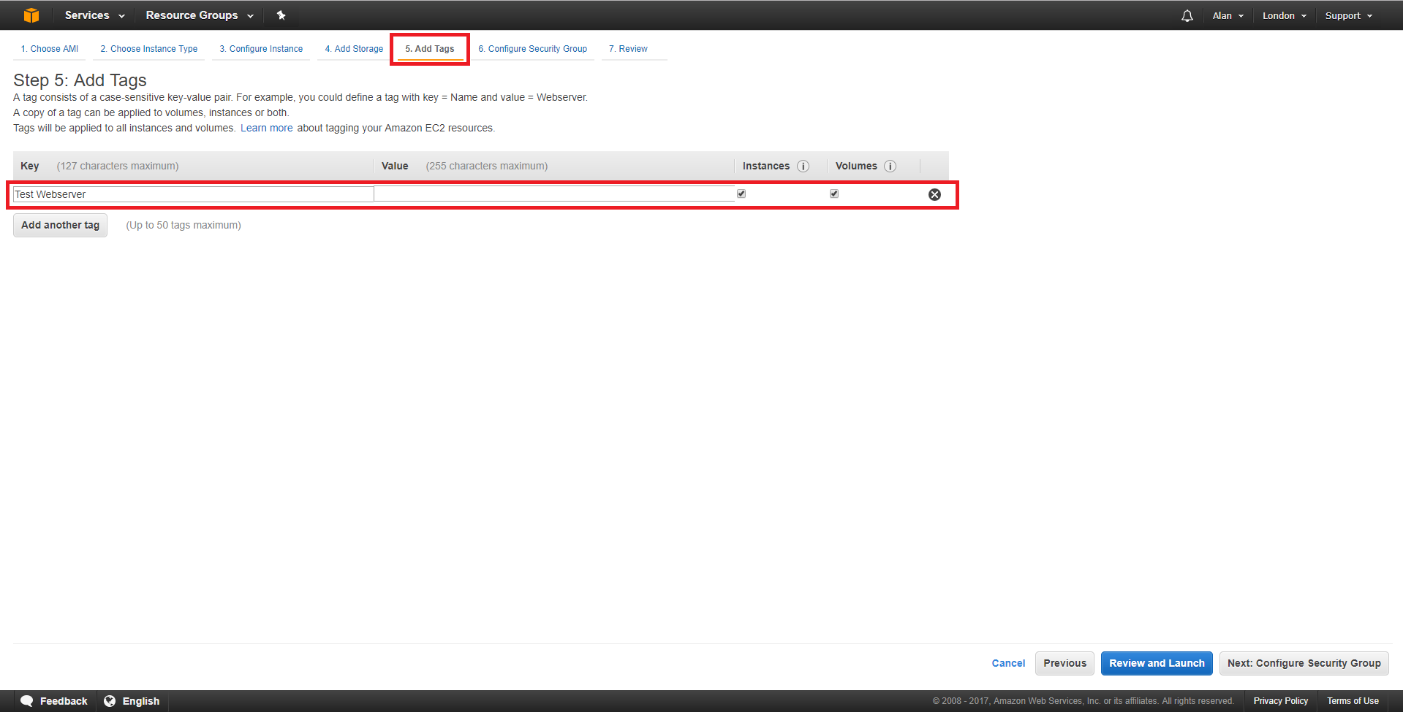
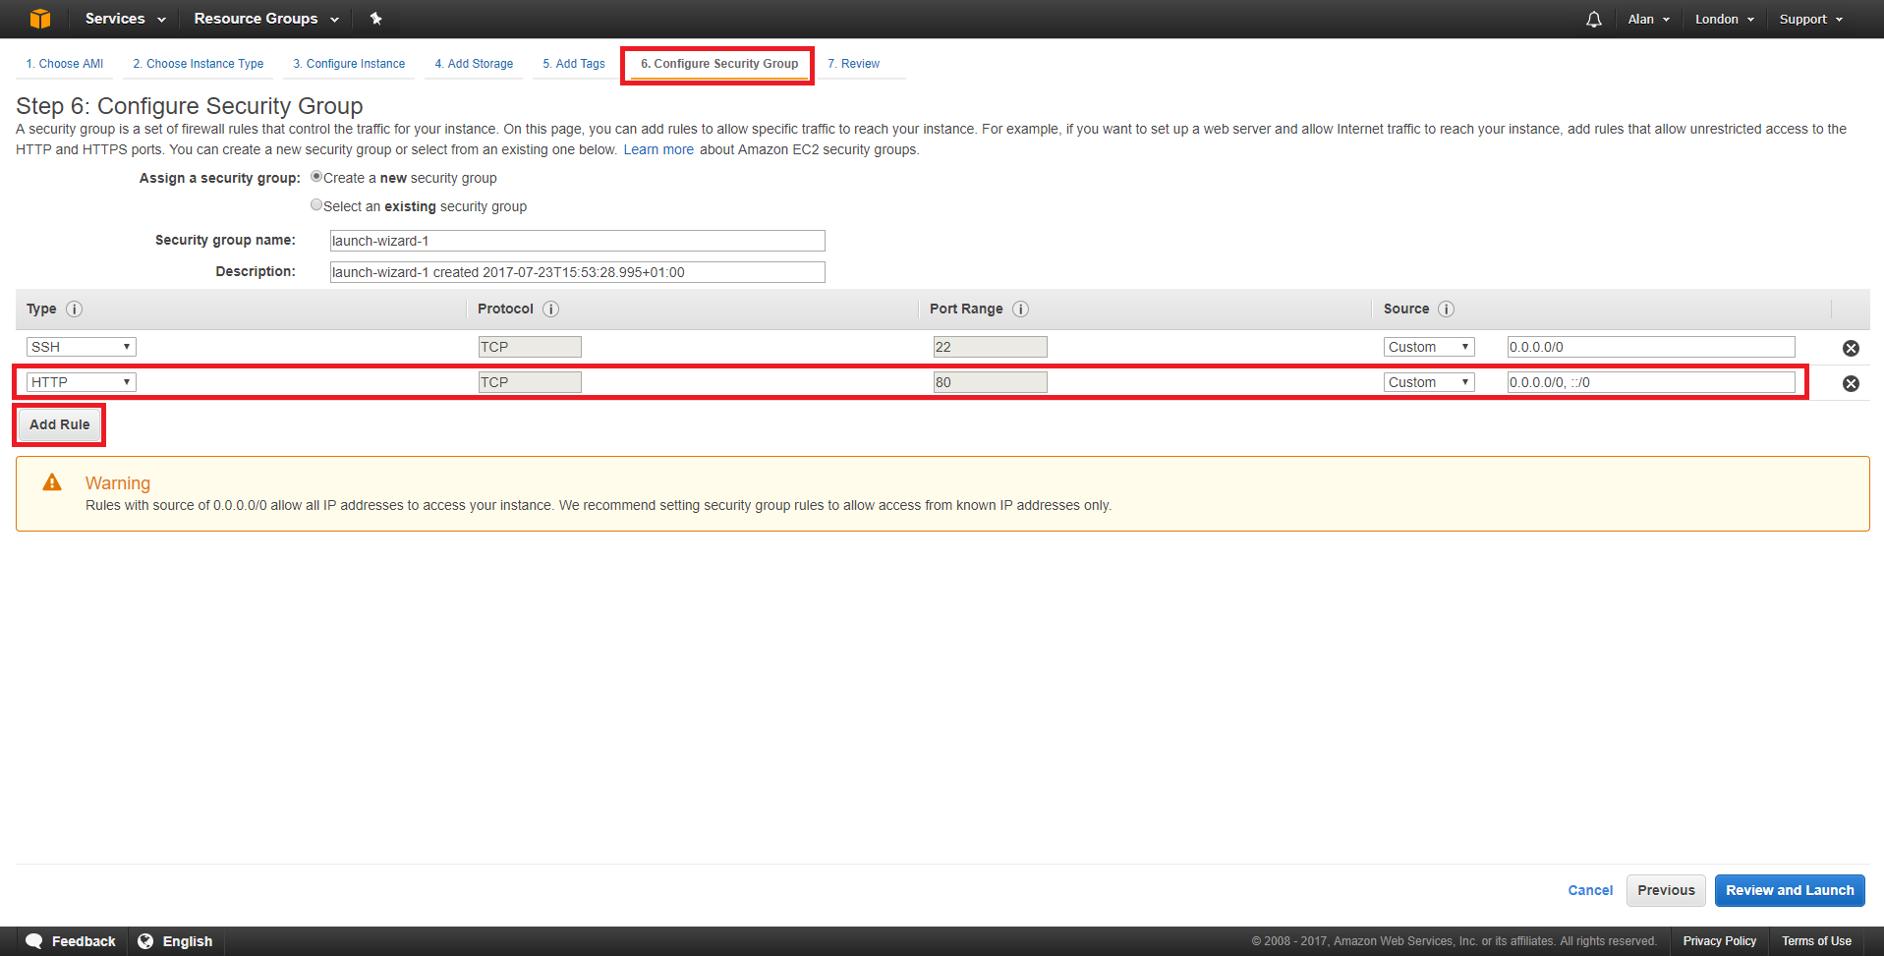
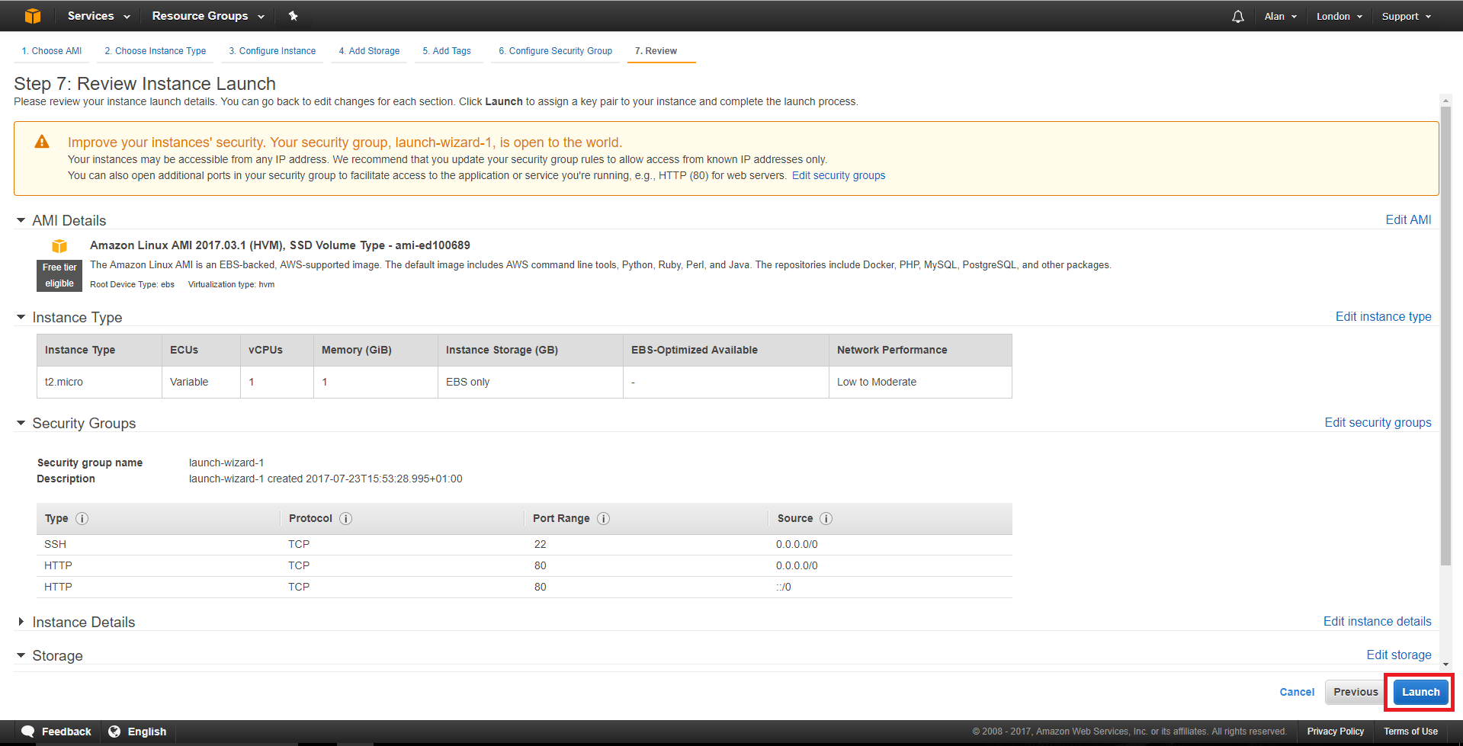
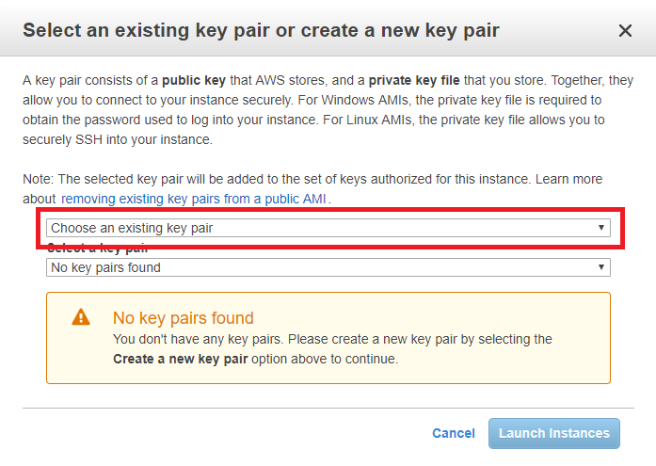
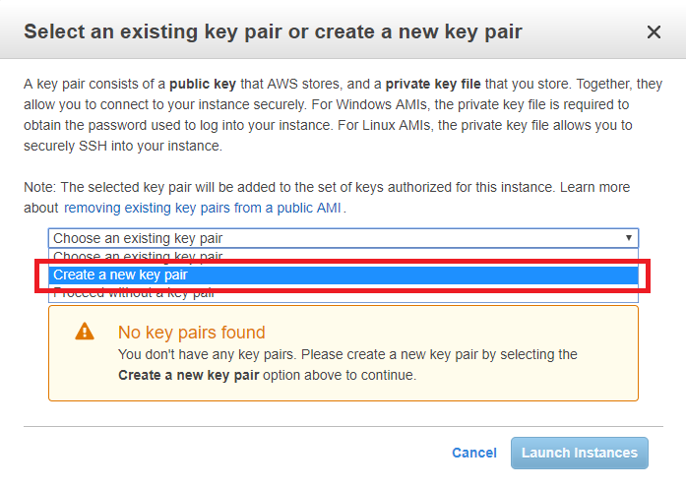
Once logged in you will see the following page (be warned, the site layout changes quite frequently, so you might have to do some digging).
The first mistake I made was not checking the region in which I was creating my AWS instance. So I created mine in the USA. Not that this really matters for serving a few webpages, but if speed is important, ensure you select a region closest to you.
You can do this by clicking the current region in the top right hand corner (highlighted in Orange) and select a suitable local region.
We have to chose what we are going to create.
From the top left of the page, select Services, then select EC2 from the Compute section.
Now we can select some options and launch our virtual server.
Click on the Launch Instance button.
A page with different Operating Systems will open.
I am going to use the top option of Amazon Linux AMI. It's a Linux system similar to CentOS. There are many choices of OS here, and I have not tried many of them. My intention is to use this server for a bit of testing, and I don't want it to cost me anything, so I am unsure if picking say Windows will incur any costs (I would guess it does). As long as it has a 'Free tier Available' label you should be good to go.
Select Amazon Linux AMI 64bit (Blue button on the right hand side of the page.)
Next we have to chose our instance type. This is setting up how many processors (vCPUs) memory, hard disk space etc that we want.
* DO NOT CLICK Configure and Launch * There are a lot of options here, but for those of use wanting a free server, there is only one, the t2micro (Fee tier elegible) so that makes our decision process pretty simple.
Select Configure Instance Details from the bottom right of the page.
Before we launch our instance, we can make some changes. Click the Add Storage tab.
By default you get a storage area of 8GB, if this is not enough then you can increase it. There is an information box that states (at the time of writing) you can have up to 30GB free. Remember, if you pan to have more than one EC2, you have to split that across them.
I left my configuration at 8GB.
Click the Add Tags tab.
You don't have to do this, but if you are going to have a lot of instances, it does become necessay. Just add a name for this instance (I used Test Webserver.)
Click the Configure Security Group tab.
You can look at security groups as a firewall. All ports are closed unless you open them. By default port 22 (SSH) is open, or you would have no access to your OS. As this is going to be a web server, I will also open Port 80.
Click Add Rule and select HTTP as the type. 0.0.0.0/0, ::/0 means accept traffile from any IP Address. For the SSH I would limit that to your own IP (say your work or home IP).
Now you can select Review and Launch.
You will be shown a review screen of your selected settings.
If you are happy, select Saunch in the bottom right hand corner of the page.
You will be presented with a pop up that is asking about Key Pairs. When using SSH, key pairs are used rather than a simple username and password as key pairs are much more secure.
Where you see Choose an existing key pair, you need to change this to Create a new key pair.
Select a new for the new key pair, and click the Download Key Pair button.
You will see the .Pem file download (this is browser specific).

