T1 Chassis
T1 2000 Series platform based on Kontron SymKloud MS2900 chassis.
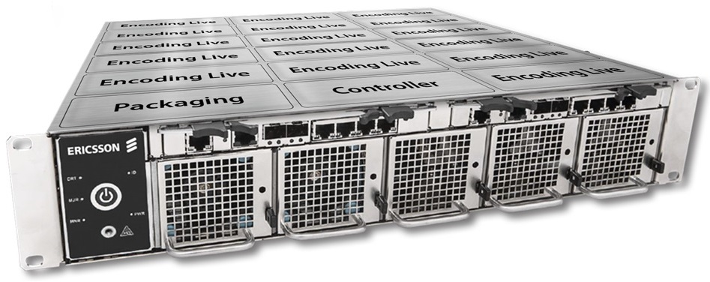

The T1 is a new platform based on a server that can have up to 9 Blades fitted. Each blade contains two separate servers. The T1 main differentiator (at launch) is that it is the first platform that can take advantage of the QSV (Quick Sync Video) feature of the Intel Processor.

Quick Notes
The T1 Chassis has a lot of functionality not normally found in any traditional products, or in the Gx line of servers so far (G5, G6, G7, G8 etc) (with the exception of one of the UHD servers from 2016). The T1 is a chassis that comprises a number of blades, and two switches, where most of the ports are internal to the Chassis.

Chassis Front View
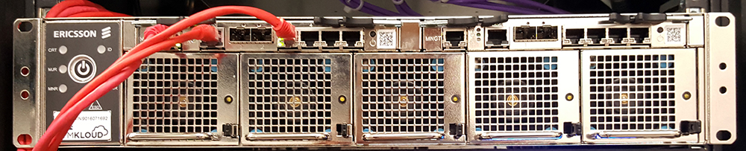
The front of the T1 Chassis has five removable fans (hot swap), the power button and access to the two switches. The unit does automatically power up when the power cables are inserted. The power cables are the type that have a notch in them, so standard IEC cables will not fit.

T1 Switches
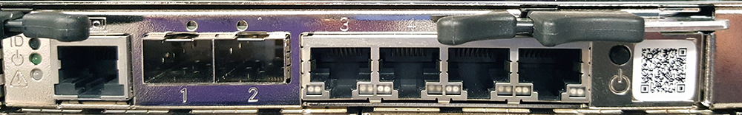
The two switches at the top of the T1 Chassis allow access to the switch management, and to the Blade Servers. The T1 Switches each have 27 ports, but we can only access 7 of them from the front panel (strictly one of them is a serial port, so 26 IP Ports).
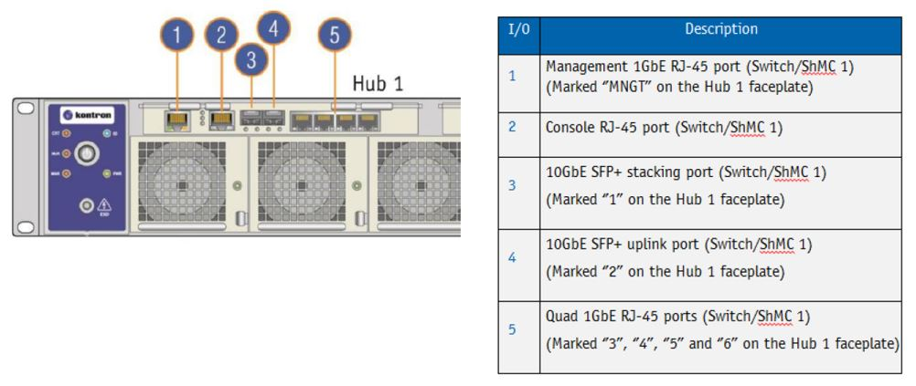
The initial switch configuration is done via the Console port (2) which is an RS-232 port (same style as the Cisco console port) running a 115200.
Port (1) allows access (once an IP Address has been assigned via the console port). The two switches are linked internally, and so from a single Management port you can access the Web UI of both Switches.
When you connect to the Switch Web UI, navigate to Monitor→Ports→State to see the following:
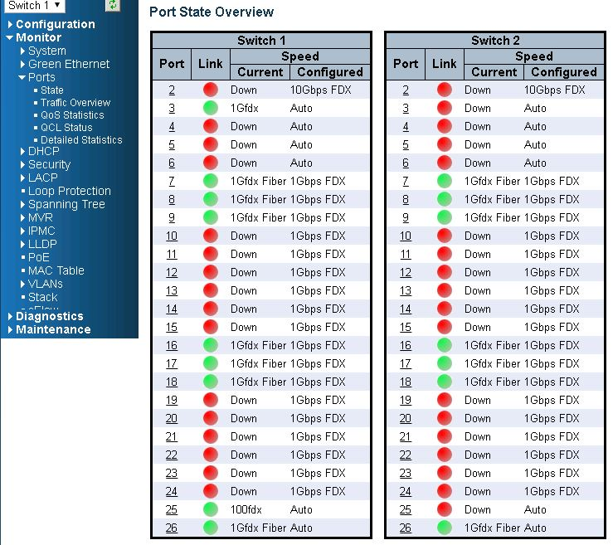
To see which internal port and external port is connected, and to where, refer to the following diagram.


