Simple and Test Projects

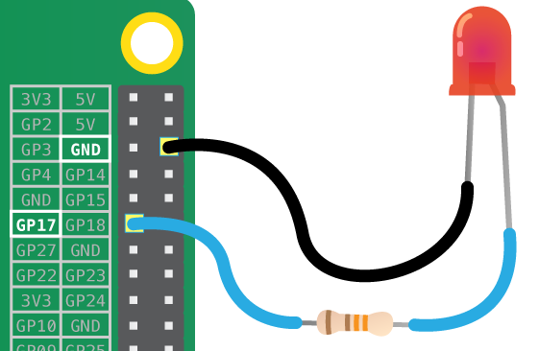

Here is a collection of projects that are really part of a bigger project, but that might be useful for your projects, e.g adding an LCD screen or using a GPIO pin.
- Two Line LCD Character Display
- I²C LCD Display
- 2.5" SPI LCD Display
- GPIO LED Control
- GPIO Inputs - Button LED Control
- GPIO Inputs - LED Control via a button and Interrupt
- GPIO Control from Command Line
- LED PWM Control
- How to use a Stepper Motor
- Remote Fire Camera via GPIO

