MFCP
Nov 2017

Media First Content Processing

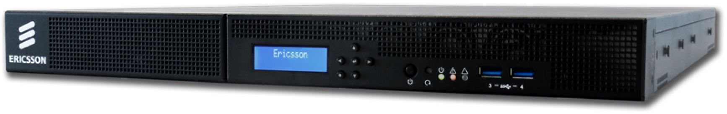{{:t1_chassis.jpg?500|

MediaFirst Content Processing addresses the fast-changing needs of Contribution and Distribution customers who want to offer Next Generation 4k video services within an all IP environment. In its initial phase Content Processing will address the need for 4k video, outputting decoded video over IP interfaces using the new SMPTE 2110 standard. As a highly flexible implementation it allows for pay-as-you go OPEX sales models within virtualized infrastructures whilst offering uncompromised performance.

- Login Details

