IGMP Snooping Groups
Apr 2024

When using IGMP snooping, it can be very useful to see what is happening on the switch. In this example, we can look at a Cisco switch being used in an nCompass Controlled Aquila Live system. It does not matter that we are using nCC, this will look the same on just a Controller based solution also.
Please bear in mind that this system is 1+1 Encoding Live and 1+1 Multiplexers that are using:
1. Statistical Multiplexing
2. Services Synchronisation
3. Dual Output Prevention
This is important to know because we can see the multcasts for each of these processes.

IGMP Snooping Groups
Once you have logged in to your switch (in this example I am using a Cisco switch) you can issue this command from the top level (no need to go in to the configuration mode).
show ip igmp snooping groups
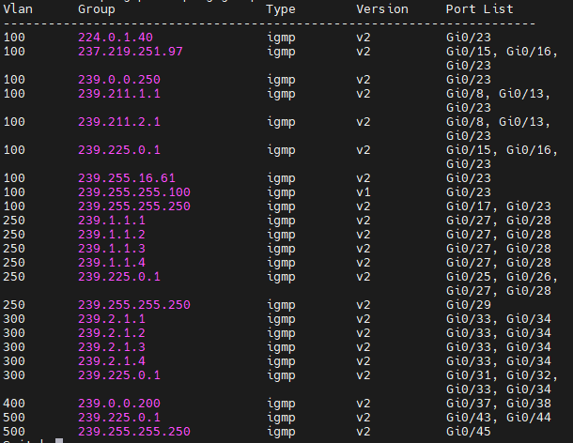
The VLAN column is which VLAN each of the interfaces is in.
VLAN 100 - Management (the management interfaces of each server are teamed)
VLAN 250 - Primary EL output and Mux input
VLAN 300 - Secondary EL output and Mux input
VLAN 400 - Mux output VLAN
We can pick out of the list certain Multicast Groups and their function:
Vlan Group Type Version Port List
-----------------------------------------------------------------------
100 239.211.1.1 igmp v2 Gi0/8, Gi0/13, Gi0/23 - Services Synchronisation (EL)
100 239.211.2.1 igmp v2 Gi0/8, Gi0/13, Gi0/23 - Dual Output Prevention (EL)
100 239.225.0.1 igmp v2 Gi0/15, Gi0/16, Gi0/23 - StatMux Announcer (EL <-> Mux)

250 239.1.1.1 igmp v2 Gi0/27, Gi0/28 - Service 01 Multicast (Primary EL)
250 239.1.1.2 igmp v2 Gi0/27, Gi0/28 - Service 02 Multicast (Primary EL)
250 239.1.1.3 igmp v2 Gi0/27, Gi0/28 - Service 03 Multicast (Primary EL)
250 239.1.1.4 igmp v2 Gi0/27, Gi0/28 - Service 04 Multicast (Primary EL)
250 239.225.0.1 igmp v2 Gi0/25, Gi0/26, Gi0/27, Gi0/28 - StatMux Announcer (EL <-> Mux)

300 239.2.1.1 igmp v2 Gi0/33, Gi0/34 - Service 01 Multicast (Secondary EL)
300 239.2.1.2 igmp v2 Gi0/33, Gi0/34 - Service 02 Multicast (Secondary EL)
300 239.2.1.3 igmp v2 Gi0/33, Gi0/34 - Service 03 Multicast (Secondary EL)
300 239.2.1.4 igmp v2 Gi0/33, Gi0/34 - Service 04 Multicast (Secondary EL)
300 239.225.0.1 igmp v2 Gi0/31, Gi0/32, Gi0/33, Gi0/34 - StatMux Announcer (EL <-> Mux)
400 239.0.0.200 igmp v2 Gi0/37, Gi0/38 - Mux Multicast Output

