How to SAVE MONEY on your PCBs

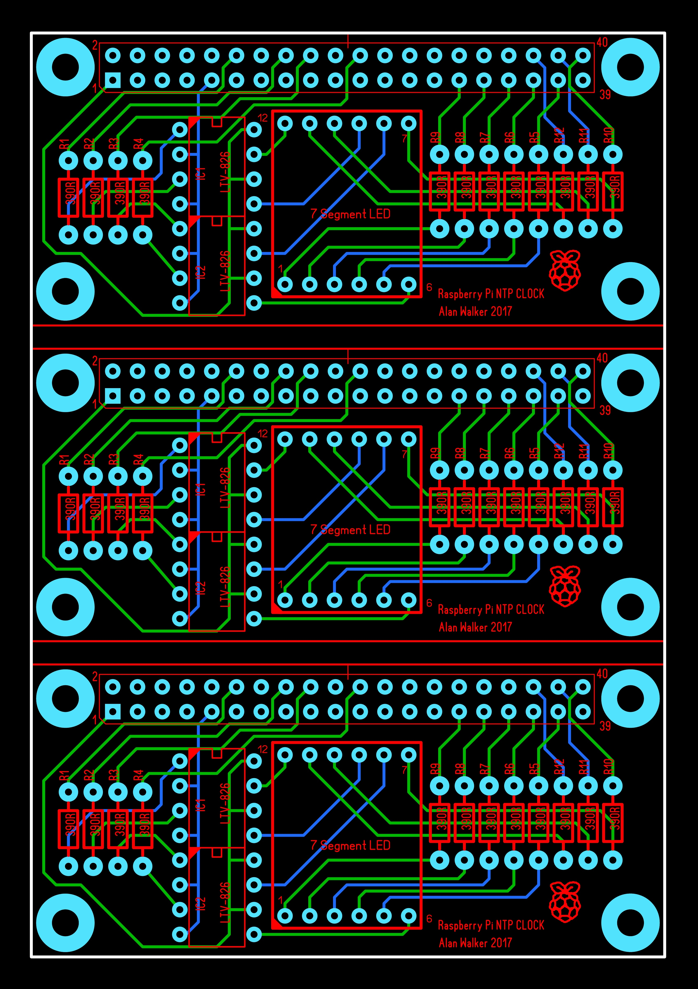
So the PCB files on the previous pages are perfectly valid. BUT I noticed something when ordering PCBs from certain manufacturers. The PCB for this project is 65x30mm, I noticed that the price does not change if you go up to 65x95mm (I think up to 100x100mm the price is the same) so you can fit three PCBs on one 'sheet' if you like, thus tripling the number of boards you get for the same price. You will have to cut them yourself, but we are talking about 2 cuts, how hard can that be?
There is a zip file here with three boards in one PCB file, that you can use. It looks slightly different because with the help of a friend the layout has been tidied up a bit, but any of the boards are electrically valid.
Download Triple Board HERE.
This is what the PCB looks like.

