Creating a single MPG4 output
Apr 2020

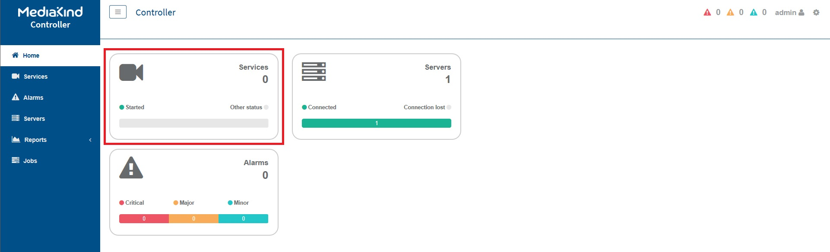
In this example we will look at how to create a single MPG4 output from an input file. This guide assumes that you have a working MK Encoding on Demand and have some local or shared files to encode. This guide also assumes you have used MK products before and are at least a little familiar with the Controller interface.
Log in to the MKEO to see the normal Controller view.

