Connect to Server via MGMT Port
Oct 2017

Once a valid IP address has been assigned to the MGMT (1) Port, shown below:
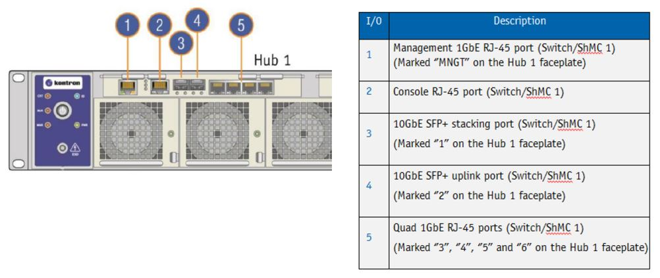
Then we can connect to the Management UI of the switch, this allows us to configure the ports of the Swithch, what VLANs exist etc.
However, another beneficial aspect is that we can communicate with any of the installed servers via this port. So form a single IP Address we can gain console access to any installed OS, and use command line tools.
Navigate to the IP Address of the MGMT port on the Switch (can be either switch, they are connected internally).
http://ipaddress/shell/
Ensure you have a / after the word shell/
You will see a login prompt:
MSH8900 login:
Login using the details below:
console
admin
You will now see the following Promt:
Please enter the Node number [1-9] or Switch [S]:
The Node number [1-9] refers to the Blade number, see below for blade numbering:
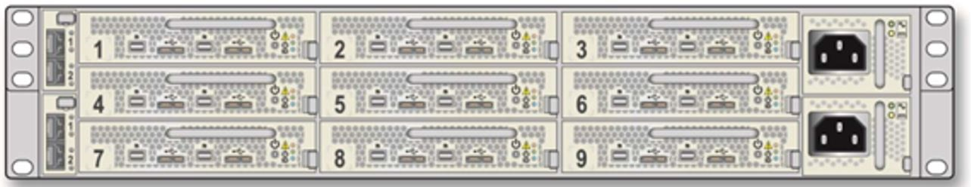
I am going to talk to Blade 1, so enter a 1.
You will see a confirmation:
Selected node 1.
Next you will see the following prompt:
Please enter payload number [1-2]:
The payload number [1-2] refers to the server on the blade. Each blade has two servers, see the diagram below for server numbering.
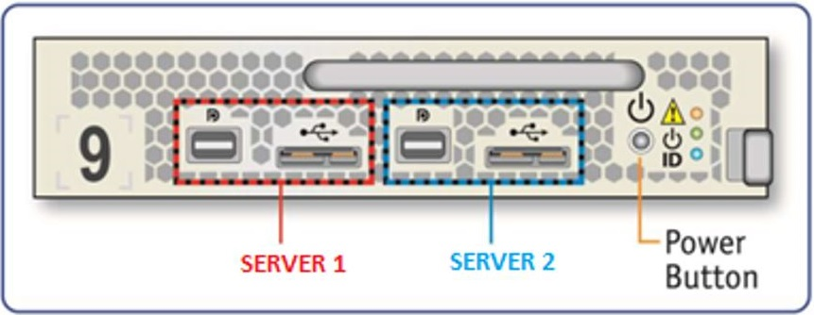
I am using server 1, so enter 1.
You will see the following confirmation:
selected Payload 1.
You might see the following error at this point, you can safely ignore this.
Using HPM.2 Draft extension for SOL
Info: 2 SOL instances available
Info: SOL payload already de-activated
Using HPM.2 Draft extension for SOL
Info: 2 SOL instances available
[SOL Session operational. Use ~? for help]
** Console dropped due to BP Com request *

(you may have to enter login details of installed OS)
Press enter
You now have command prompt

