2.5" SPI LCD Display
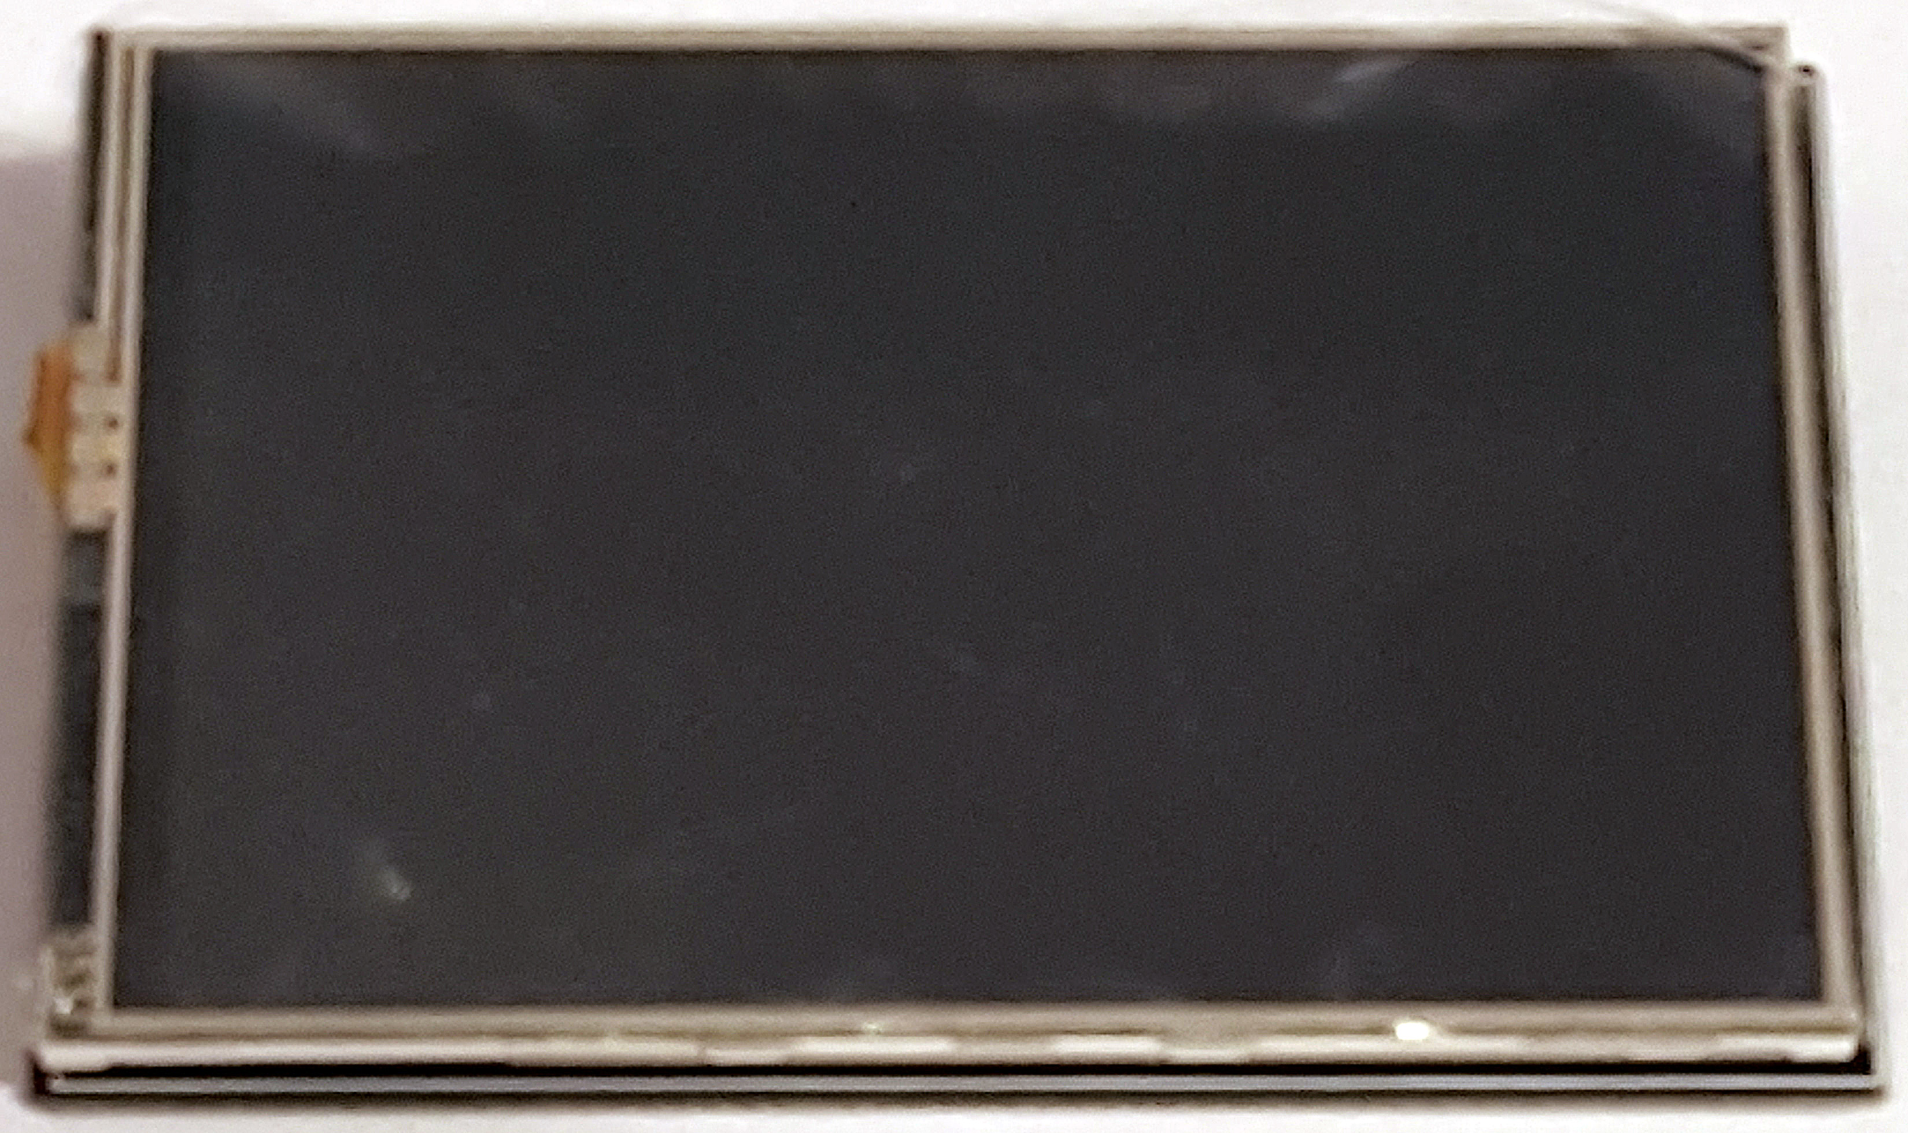
At around £8, adding a full function LCD display to a Raspberry Pi that is running without any attached monitor is a great way to add a bit of simple monitoring, or if required a more complex control system for stand alone projects.
The main issue with many displays is drivers (libraries) as these can be impossible to find, and even then sometime they are unreliable. If support is the most important thing, then buy the official Raspberry Pi display (Circa £50). But if you don't mind a small amount of fiddling, then here is a guide to a cheap LCD I bought from eBay.
The main reason I bought this display was that the header only uses 12 pins, and leaves access to the remaining header pins. The drivers are available online, although they are a bit fiddly, mainly its easy to lose the display if you do an apt-upgrade. However, once a stand alone project is complete, it is unlikely that you will update it (why would you if it still works?)
Follow these steps to install the LCD (assuming you have the same model)
1. Download the library:
The most up to date driver will be here (https://drive.google.com/folderview?id=0B0DYHppEJ9cHbnRzSk9oUVAyMkk&usp=sharing)
Or you can use: {{ :lcd_show_v6_0_2.tar.gz |}}

